

The IARU Region 3 Newsletter

Issue 58– Quarter 1 2021

Editor’s Note

Welcome to the first IARU-R3 newsletter for 2021.

As you will see, you have a new Editor. Our previous Editor, Peter, VK3MV has, for health reasons, had to retire from his IARU roles. We thank Peter for his many valuable contributions to IARU matters, wish him all the best, and look forward to working him on the bands.

This is Your Newsletter!!!!
Many Member Societies are doing things that are of interest to other Amateurs in Region 3. All Societies are encouraged to send their news items to the Editor (don@iaru-r3.org) so we can include them in this newsletter.

We are also keen to receive digital photos of amateur related activities to be used in this newsletter and other publications. Please contact the “Editor” if you can assist.

The deadline for the next edition is 30 June 2021.

Stay Safe

73 Don ZL2TLL

A Word from the Chairman

Dear IARU Region 3 colleagues

The 2nd Meeting of the Asia Pacific Preparatory Group for the World Radio Conference 2023 (APG23-2) was held virtually from 19 April 2021 - 23 April 2021.

This APG23-2 discussed many topics (see report below) including:
- Review of the working methods of APG;
- Nomination for the Chairmen of Drafting Groups on individual WRC-23 agenda items;
- Consideration of the study progress in ITU-R Study Groups;
- Review of the preparation of ITU and other regional organizations for WRC-23; and
- Discussion and adoption of the APT Preliminary Views on WRC-23 agenda items and issues related to RA-23.
I hope all member societies in Region 3 have started to work with their respective administrations to garner support for the agenda items that the IARU are promoting.
If your society have inputs or suggestions for our preparation for WRC-23, please do not hesitate to contact the IARU Region 3 Secretary and Directors.

Thank you and 73 de Wisnu YBØAZ
Chairman of Directors of IARU Region 3

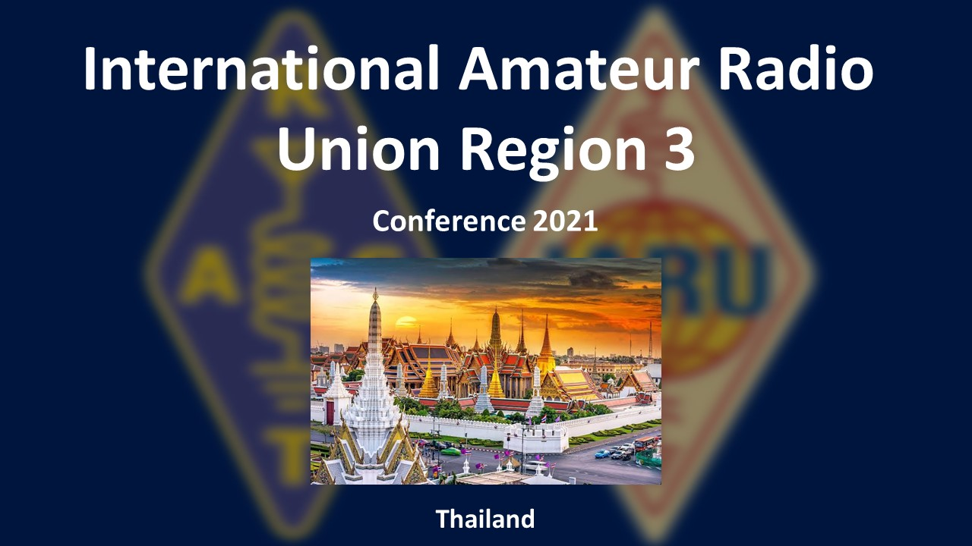

IARU Region 3 Conference - A Virtual Meeting

The need to hold meetings virtually is still very much a part of the amateur life as COVID 19 continues to make it difficult to get together in person.

As Member Societies will be aware, your Directors have decided that it is not possible, given the COVID situation, to hold our planned in-person Region 3 conference in Thailand and we have, instead, asked RAST to host an online Zoom meeting.

Preparations are well under way for the meeting. The Secretary sent out an Invitation to Member Societies on March 15 and RAST has set up a website (https://www.iarur3conf2021.org/) for the Conference.

The website already has some background information on it and will be regularly updated so please access it if you would like up-to-date information on the Conference.



Report on APG23-2

The 2nd Meeting of the APT Conference Preparatory Group for the World Radio Conference 2023 (APG23-2) was held virtually/online from 19 to 23 April 2021. The meeting was organized by the Asia-Pacific Telecommunity (APT).

More than 700 people were registered from 26 APT Members, Associate Members, Affiliate Members, and International Organizations including IARU Region 3. In the Opening and Plenary session around 500 people were on the Zoom screen.

The Chairman of IARU Region 3 Directors. Wisnu Widjaja and the Secretary of IARU Region 3 Shizuo Endo attended the meeting as representatives of IARU Region 3. Region 3 Directors Ken Yamamoto and Don Wallace along with Dale Hughes of the WIA attended as members of their administration’s delegations.

Due to time constraint, most agenda items were discussed only one time at the relevant first WP/drafting groups and output documents which include APT preliminary views were drafted. No substantial discussions were made. We expect to see more specific APT preliminary views at the next meeting.

R3 Secretary Shizuo Endo JE1MUI


IARU World Radio Conference 23 Mailing List

IARU Region 3 has set up a mailing list to keep Member Societies up to date with matters to be discusses at the 2023 Word Radio Conference (WRC-23).

The latest documents sent out to members were:
- WP4C IARU internal report of Feb. 2021 meeting relevant to AI 9.1 b)
- APG23-2 INF-23 IARU Position paper for WRC23 Ais
- R19-WP5A.AR-C-0098 IARU Position Paper for WRC23 AIs
If you would like further information or wish to join the mailing list, please contact the Secretary (secretary@iaru-r3.org).

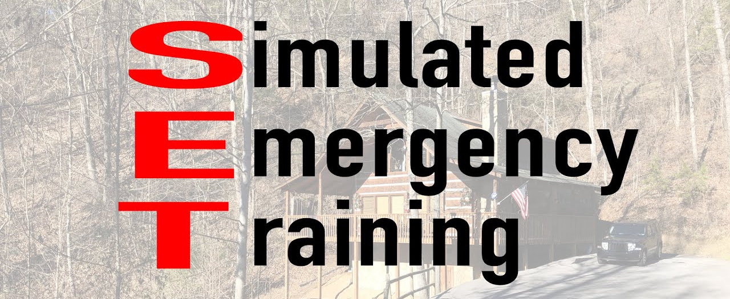

Region 3 Simulated Emergency Test (IARU-R3 SET)

The IARU-R3 Disaster Communication Committee (DCC) is planning to hold a simulated emergency test (SET) later this year.

The idea of SET is to give Amateurs in Member Societies practice in handling radio traffic in disasters so that, when an actual disaster occurs, we have a group of trained people who can assist the affected Member Society.

R3 Standard Operation Procedure for Disaster Communication in Region 3 will be used –

Member Societies were sent an invitation in January and again in April asking them to nominate their liaison person for the exercise but there has been little interest so far.

To create awareness of what a SET is and how important it is to have prepared Member Societies, the DCC plans to hold a regular 40 m net from May onwards and, once sufficient Member Societies are on-board, to put in place the first Region 3 SET.

All Member Societies are asked to advise who will be their contact person for the exercise, ASAP, to the Chairman of Disaster Communication Committee, Emir Yudha Amangku YB0LBT (disaster-chairman@iaru-r3.org).

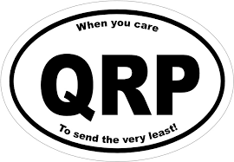

QRP Day

Back in 1997, IARU Region 3 agreed that Region 3 Societies should help to promote the IARU objectives for QRP operation:
- to support QRP operation on June 17 each year;
- to foster QRP activities by their members;
- to encourage regular publication of QRP articles in their national magazines;
- to provide QRP sections in any national contests; and
- to assist other Societies with the promotion and development of QRP."
As part of this, JARL operates the special event stations 8JxVLP (x is an area number) in May/June every year to promote QRP operation.



IARU HF Championship

The 2021 IARU HF World Championship Contest takes place the second full weekend of July, beginning 1200 UTC Saturday and ending 1200 UTC Sunday (10-11 July 2021). Both Single and Multi-operator stations may operate the entire 24-hour period.

All licensed amateurs worldwide are eligible to participate in this contest. The objective of this contest is to contact as many other amateurs as possible, especially IARU member society HQ stations, around the world using the 160, 80, 40, 20, 15 and 10 metre bands. Multipliers are the total number of ITU zones plus IARU member society HQ stations worked on each band (not mode). Thus, your Society's HQ stations participation is particularly important for the multipliers.

The HQ stations in IARU Region 3 which participated in the 2020 contest were 8NxHQ, DX0HQ, E2HQ, 7A1HQ, ZL6HQ, AT1HQ, VK3WIA, BV0HQ and VR2HK.

JARL HAM Fair 2021
"Jump out to the new era, Youngsters!!"

The JARL Ham Fair 2021 will be held at Tokyo Big Sight, Ariake, Tokyo on Saturday October 2 & Sunday 3 October 2021.

In 2019 (the 2020 JARL ham fair had to be cancelled due to COVID-19) JARL had about 42,000 participants over the 2 days.

More information is available on JARL website:
https://www.jarl.org/English/4_Library/A-4-6_ham-fair/ham-fair.htm



Region 3 to set up Internet Forums

At the last Region 3 Conference, Directors were asked to set up a mechanism for Member Societies to use for sharing information on Amateur Radio.

At the end of January, the Secretary sent out a letter describing the system to be used and seeking suggestions for topics for the forums. Responses were received from two societies and it was decided that forums for the following topics would be set up:
- Electromagnetic Interference (EMI) including man-made noise,
- Capacity-building of youth in R3 in amateur radio,
- National Regulations on Amateur Radio.
The forums are currently being set up and further information will be provided once they are ready.

Intruder Monitoring System

Around the world, a number of Member Societies contribute reports on stations that are intruding into our Amateur bands. Monthly reports on these intruders are compiled and uploaded to the Region 3 website. (https://www.iaru-r3.org/about-us/committees-and-working-groups/iaru-region-3-monitoring-system-newsletter/)

We are keen to increase the number of reports from Region 3 so if your Society can assist, please contact the Region 3 Monitoring System Coordinator (Titon Dutono, YB3PET) at monitoring-coord@iaru-r3.org

Silent Keys

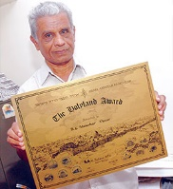
It is with deep sadness and regret that we advise that VU2UR Manohar Arasu, former Monitoring Manager for R3 became silent key on April 28 due to Covid.

Manohar was a Life member of Amateur Radio Society of India (ARSI) and was the Frequency Monitor for several years filing intrusion reports with the IARU-R3 representing ARSI. He was well known in Amateur circles and had won more than 1200 certificates and plaques and received recognition from organizations across the globe.

IARU Region 3
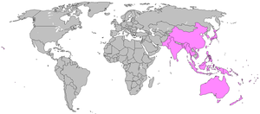

Society Update Officials and Contact Information

As a part of the move to new International and Regional websites, all IARU Member Society information is now hosted on the International Secretariat website at https://www.iaru.org/reference/member-societies/ .

We are aware that some details have not been updated for a number of years and have incorrect information.

All Region 3 Member Societies are asked to check their entries to ensure that all details about their society are up to date and to
Please send any updates to the IARU International Secretariat (secretary@iaru.org) with a copy to the Region 3 Secretary (secretary@iaru-r3.org)

IARU Region 3 Contacts

Official R3 Contacts. Further information can be found on the Region 3 website: http://iaru-r3.org/contacts/

Back Issues:

Back issues of the newsletter are available on website
http://iaru-r3.org/topics/newsletter

Editor:

Don Wallace, ZL2TLL, Director IARU Region 3.
E-mail: don@iaru-r3.org

Publisher:

The International Amateur Radio Union Region 3
P. O. Box 73, Toshima, Tokyo 170-8691, Japan.
E-mail: secretary@iaru-r3.org
Tel: +81 3 3988-8753 Fax: +81 3 3988 8772

The statements or opinions in this Newsletter do not, unless otherwise stated, necessarily reflect the views of IARU Region 3, the Directors, or the Secretariat.

Note to Editors - Items from this Newsletter may be freely copied for publication by Member Societies of IARU.

