

The IARU Region 3 Newsletter

Issue 56– Q3 2020, Released October 2020

Editor’s Note

Thank you to all those who have contributed to this edition of the Region 3 Newsletter.

The R3 Directors have undertaken the annual virtual meeting last week. See the News Release. The Region 1 Conference will take place this coming week as a virtual meeting. In addition, the IARU Administrative Council (AC) meeting that normally takes place around the time of the various regional conferences will be held over 8 – 10th October.

Request

The IARU R3 would like to receive digital photos of amateur related activities to be used in its media related publications. Please contact the “Editor” if you can assist.

Next Newsletter
Societies are invited to submit news items that may be of interest to readers. The deadline for the next edition is 31th December 2020.
Stay Safe

73 Peter, VK3MV

A word from the Chairman

Dear IARU Region 3 colleagues,

It has come to the attention of the International Amateur Radio Union Region 3 that at multiple times in the last several years, there is an increasing number of HF intruders radio transmissions with excessive power level, bandwidth and inappropriate mode operating on frequencies inside the exclusive amateur bands allocated to the amateur service especially at 40 meter band.

Those operations have led to harmful interference to radio amateur communications services in the IARU Region 3 area.

I’d like to ask to all member societies to get involved in this matter and cooperate with your administrator and ask them to take enforcement action in this matter if needed.

We need to work together to protect our spectrum from intruders and inappropriate use.
Thank you and 73 de Wisnu YBØAZ
Chairman of Directors of IARU Region 3

IARU Region 3 Directors’ Meeting 1st – 2nd October 2020
News Release

The Chairman of IARU Region 3 directors, Wisnu Widjaja YBØAZ and the directors Ken Yamamoto, JA1CJP, Peter Young, VK3MV, Don Wallace, ZL2TLL, Jakkree Hantongkom, HS1FVL, Mohd. Aris bin Bernawi, 9M2IR and

the IARU Region 3 Secretary Shizuo Endo JE1MUI met on
Zoom for their annual Directors’ meeting on 1st and 2nd October, 2020. They were partially joined by IARU President Tim Ellam VE6SH and Vice President Ole Garpestad LA2RR.

This annual meeting has been originally planned to be held for the 1st to 3rd of October 2020 in Thailand. However, the Corona virus pandemic forced us to change it to a virtual meting from an in-person meeting.

The directors and secretary reviewed progress on tasks directed and allocated to them.

The finance situation of the region was noted to be healthy and well within budgets set earlier.

Reports were received from the Chairman, Directors and the Secretary. They mainly reported subjects on the responsibilities allocated to each of them.

Reports were also received from the Region 1 president, Region 2 secretary and, the Region 3 committee chairmen and coordinators of Monitoring System, Beacon, Bandplans, Disaster Communications, EMC & EMR, ARDF and Award manager.

Verbal report was also received from the IARU president. His report included topics about financial status in IARU, the
appointment of assistant international secretary, IARU globalization and protection of spectrum for amateurs. He also pointed out that the way in which some societies operate may need to adjust.

The Region 1 report includes issues on pressures to amateur bands from commercial organizations, future of amateur radio and IARU organization, youth activities, administrative issues in their region.

The Region 2 report includes issues on workshop related to emergency communications, future of IARU, youth activities and band planning to cope with the demand for digital spectrum.

The following are major conclusions of IARU Region 3 at this meeting.
- The finance situation of the region is healthy and well within budgets set earlier.
- The issues of future of amateur radio and IARU organization structure initiated by IARU officers are important to amateurs and societies in Region 3.
- To retain amateur bands is essential to amateur activities. For this, each society is encouraged to keep good contact with its administration.
- In attending to APT Conference Preparatory Group for WRC-23 (APG23) meetings, it is required to follow the IARU common position authorized by the AC (Administrative Council).
- It is recognized that the revision of current R3 Bandplan is necessary to keep harmonization with those of other regions, especially in 40 m band digital modes. It is also recognized that to gather information of 23 cm band status and usage is needed for WRC23 Agenda Item 9.1b preparatory works.
- Some IARU Region 3 societies have been inactive for the past some years and the Directors should find possible measures to enable the amateurs in these countries to be involved in IARU activities.
- Region 3 SET (Simulated Emergency Test) should be set up as soon as possible to practice domestic/international emergency communications. The details will be announced on the Region 3 website and sent to every society once all necessary documents are completed.
- To respond to the Recommendation adopted at the last Region 3 Conference, an intruder watch report form was drafted. The form will be posted to the Region 3 website and sent to Region 3 societies once the form is completed.
- Region 3 YOTA program, which was scheduled this October in Thailand was cancelled due to the Corona virus pandemic, is to be rescheduled in next year. However, depending on the Corona virus pandemic situation, the program would be made via online rather than in person.
- Discussion was made about how the 18th Region 3 Conference should be held. If holding in-person Conference is not appropriate due to the Corona virus pandemic, holding of online Conference should be considered. Final decision will be made by the end of March 2021 considering the required advance notice date to the Region 3 societies, and the IARU and other Regions executives.
- Before the 18th Region 3 Conference, virtual Directors’ meetings are planned for December 20th, 2020, February 28th, 2021 and May 23rd, 2021. The next annual Directors’ meeting is planned for October, 2021 in conjunction with the Region 3 Conference.

Chairman of IARU Region 3 directors, Wisnu Widjaja YBØAZ,
Secretary of IARU Region 3, Shizuo JE1MUI

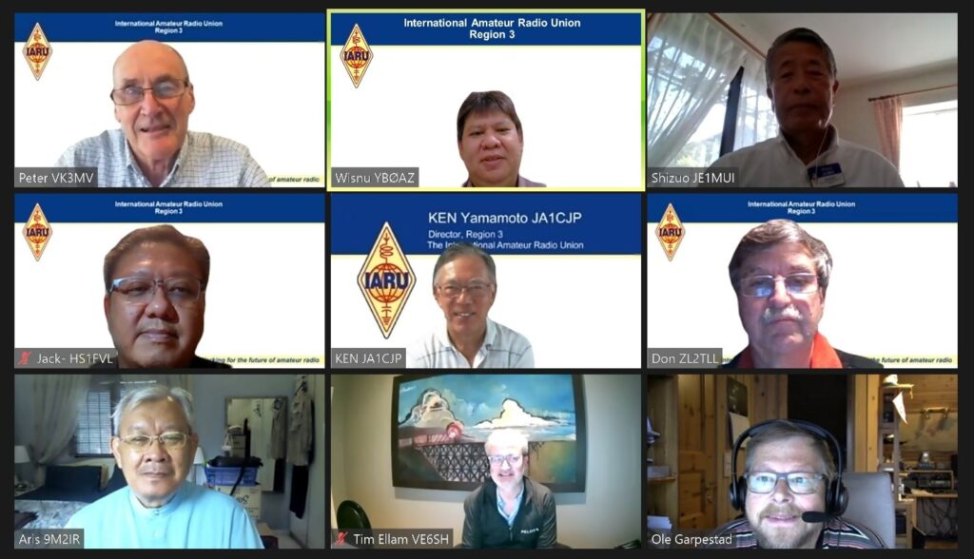
Peter VK3MV Wisnu YB0AZ Shizuo JE1MUI
Jakkree HS1FVL Ken JA1CJP Don ZL2TLL
Aris 9M2IR Tim VE6SH Ole LA2RR

ITU Radio Regulations 2020 released
The ITU has made the Radio Regulations 2020 available as a free download
The ITU Radio Regulations facilitate equitable access to and rational use of the natural resources of the radio-frequency spectrum and geostationary satellite orbits. They also ensure the availability of the frequencies provided for distress and safety purposes and assist in the prevention and resolution of cases of harmful interference between the radio services of different administrations. Further, the regulations facilitate the efficient and effective operation of all radiocommunication services and, where necessary, regulate new applications of radiocommunication technology.
ITU Radio Regulations 2020
https://www.itu.int/en/myitu/Publications/2020/09/02/14/23/Radio-Regulations-2020
Direct link to Zip of PDF documents
https://www.itu.int/myitu/-/media/Publications/2020-Publications/PDF---EN---Radio-Regulations-2020.zip
ITU
HF Digital Mode Band Plan Review

Because frequency allocations and amateur radio operating interests vary in different parts of the world, the development of band plans – voluntary guidelines on the use of the spectrum that is available to radio amateurs – is a responsibility of the three IARU regional organizations. Each of the three Regions has a band planning committee to focus on this work. In recent years there have been increased efforts to bring the regional band plans into alignment wherever possible. Final approval of band plan revisions is generally given by the regional conferences of IARU member-societies that are held every three years on a rotating basis.

This approach to band planning generally has kept pace with the evolution of amateur radio operating. However, the explosive growth in HF (below 30 MHz) digital modes, particularly FT8, has led to perceived overcrowding of HF digital mode band egments. Accordingly, a working group has been formed consisting of representatives of the three regional band planning committees. This is the first time the three Regions have joined together to directly coordinate band planning efforts.

The working group has already had fruitful discussions with the WSJT Development Group led by Joe Taylor, K1JT. Additional discussions, including with other HF stakeholders, will be held as part of a fundamental review of the different HF digital modes, and how they can be best categorized and arranged to share the limited spectrum available.

The main aim is to develop solutions that reduce congestion within very popular mode segments while preventing mutual interference between incompatible modes to the greatest extent possible. While the proposed band plan revisions will have to be approved by member-societies in each Region, recent administrative changes mean that the changes can be implemented without having to wait for the regional conferences.

Amateurs are encouraged to follow progress through their IARU member-society and the respective IARU websites, all of which can be reached via www.iaru.org.

IARU

Tokyo Ham Fair Cancelled

The JARL has announced the largest amateur radio event in the world, the Tokyo Ham Fair, due to to held Oct 31 - Nov 1 has been cancelled due to Coronavirus.
The Tokyo Ham Fair was first held in 1977 at Harumi Fairgrounds which was located in Harumi, Tokyo, and has been held annually ever since. In 1996, the venue was changed to Tokyo Big Sight, which is located in Ariake, Tokyo. From 1999 to 2001, the venue was Pacifico Yokohama, located in Yokohama, Kanagawa prefecture with the event returning to the Tokyo Big Sight in 2002.
In 2019, 42,000 people are reported to have visited the event which usually takes place in August. For 2020 it was planned for Oct 31-Nov 1 because of the expected Olympic and Paralympic Games during the summer.
A translation of the JARL announcement reads:
A meeting was held on July 16 to discuss whether or not to hold the "Amateur Radio Festival Ham Fair 2020", in light of the Coronavirus outbreak.
Even if measures were taken to ensure safety in accordance with the Government and Tokyo's infection prevention measures and the "Guidelines for Preventing New Corona Virus Infection at Exhibitions, etc." published by the Tokyo Big Sight, it was difficult for visitors and exhibitors to prevent and ensure the safety of new coronavirus infections, and it was concluded that the Ham Fair should be canceled.
We are very sorry to announce that we have decided to cancel the Ham Fair 2020.
The timing of the next fiscal year will be postponed due to the postponement of the Olympic and Paralympic Games, but we will inform you as soon as the schedule and venue are decided.
Thank you for your continued cooperation.
Japan Amateur Radio League
President Yoshinori Takao JG1KTC
JARL Announcement
https://www.jarl.org/Japanese/1_Tanoshimo/1-3_Ham-Fair/2020/Ham-Fair_c.htm
2019 FB News Tokyo Ham Fair https://www.fbnews.jp/201911/ww04/

ISS 437.800 MHz cross band repeater activated

At 01:02 GMT on September 2 a cross band FM amateur radio repeater with a downlink on 437.800 MHz was activated on the International Space Station.
The Amateur Radio on the International Space Station (ARISS) announcement reads:
The ARISS team is pleased to announce that set up and installation of the first element of our next generation radio system was completed and amateur radio operations with it are now underway.
This first element, dubbed the InterOperable Radio System (IORS), was installed in the International Space Station Columbus module. The IORS replaces the Ericsson radio system and packet module that were originally certified for spaceflight on July 26, 2000.
Initial operation of the new radio system is in FM cross band repeater mode using an uplink frequency of 145.990 MHz with a CTCSS access tone of 67 Hz and a downlink frequency of 437.800 MHz. System activation was first observed at 01:02 UTC on September 2. Special operations will continue to be announced.
The IORS was launched from Kennedy Space Center on March 6, 2020 on board the SpaceX CRS-20 resupply mission. It consists of a special, space-modified JVC Kenwood D710GA transceiver, an ARISS developed multi-voltage power supply and interconnecting cables. The design, development, fabrication, testing, and launch of the first IORS was an incredible five-year engineering achievement accomplished by the ARISS hardware volunteer team. It will enable new, exciting capabilities for ham radio operators, students, and the general public. Capabilities include a higher power radio, voice repeater, digital packet radio (APRS) capabilities and a Kenwood VC-H1 slow scan television (SSTV) system.
A second IORS undergoes flight certification and will be launched later for installation in the Russian Service module. This second system enables dual, simultaneous operations, (e.g. voice repeater and APRS packet), providing diverse opportunities for radio amateurs. It also provides on-orbit redundancy to ensure continuous operations in the event of an IORS component failure.
Next-gen development efforts continue. For the IORS, parts are being procured and a total of ten systems are being fabricated to support flight, additional flight spares, ground testing and astronaut training. Follow-on next generation radio system elements include an L-band repeater uplink capability, currently in development, and a flight Raspberry-Pi, dubbed “ARISS-Pi,” that is just beginning the design phase. The ARISS-Pi promises operations autonomy and enhanced SSTV operations.
ARISS is run almost entirely by volunteers, and with the help of generous contributions from ARISS sponsors and individuals. Donations to the ARISS program for next generation hardware developments, operations, education, and administration are welcome -- please go to https://www.ariss.org/donate.html to contribute to these efforts.
ARISS--Celebrating 20 years of continuous amateur radio operations on the ISS!

Chinese Amateur Radio satellite launches delayed
CAMSAT says the CAS-7A launch has been postponed until next May, and CAS-5A until next June.

"Because of COVID-19, many things have been delayed," CAMSAT's Alan Kung, BA1DU, told ARRL. He said an announcement would be made closer to the announced launches
.
CAMSAT said last spring that CAS-7A would launch in mid-September; the launch has been postponed multiple times since first announced.

CAS-5A was predicted to launch in October. Both satellites will carry two transponders that include HF, in a configuration similar to that of the Russian RS satellites decades ago.

CAS-7A will be placed into a sun-synchronous orbit with an inclination of 98 degrees at 500 kilometers above Earth. The transponders will have a bandwidth of 30 kHz. According to the IARU amateur satellite frequency coordination page, the HF/HF linear transponder will uplink on 15 meters - 21.245 to 21.275 MHz, and downlink on 10 meters - 29.435 to 29.465 MHz. A CW beacon will transmit on 29.425 MHz. The HF/UHF transponder will uplink at 21.3125 to 21.3275 MHz, and downlink at 435.3575 to 435.3725 MHz. A CW beacon for that transponder will transmit on 435.430 MHz.

The CAS-5A nanosatellite, with a 6U form factor, carries two HF transponders and two VHF/UHF transponders. While in orbit, it will deploy the tiny CAS-5B femtosatellite, which will weigh just 0.5 kilogram.

The array of CAS-5A linear transponders will include HF/HF, HF/UHF, and VHF/UHF with 30-kHz passbands (except 15 kHz for the HF/UHF transponder).

CAS-5A will include CW telemetry beacons on HF and UHF. The HF CW beacon will be at 29.465 MHz, and a UHF telemetry beacon will be at 435.57 MHz. Other beacons include the HF/HF transponder beacon at 29.490 MHz; the HF/UHF transponder beacon at 435.505 MHz, and the VHF/UHF transponder beacon at 435.540 MHz.
Telemetry will be transmitted at 435.650 MHz. The V/U linear transponder will uplink at 145.820 MHz; the V/U FM transponder will uplink at 145.925 MHz. Terrestrial stations will access the transponders at 21.385 - 21.415 MHz.

ARRL

IARU Region 3 Contacts

Official R3 Contacts. Further information can be found on the Region 3 website: http://iaru-r3.org/contacts/

Society Update Officials and Contact Information
A request is ext As a part of the move to new International and Regional websites, all IARU Member Society information will be hosted on the International Secretariat website. A request is extended to all Region 3 Society Liaison Officers or other responsible officers to ensure that all details about their society is up to date on the listings shown at http://www.iaru.org under member societies. Some details have not been amended or updated for a number of years and have nonfunctional data.

Please send any updates to the IARU International Secretariat (secretary@iaru.org) with a copy to the Region 3 Secretary (secretary@iaru-r3.org)

Newsletter details:
Go to the IARU Region 3 Web Site http://iaru-r3.org/topics/newsletter

Editor: Peter Young, Director IARU Region3.
E-mail: peter@iaru-r3.org

Region 3 Societies can submit articles for inclusion to the next bulletin by 31th December 2020.

Publisher: The International Amateur Radio Union Region 3
P. O. Box 73, Toshima, Tokyo 170-8691, Japan.
E-mail: secretary@iaru-r3.org
Tel: +81 3 3988-8753 Fax: +81 3 3988 8772

The statements or opinions in this Newsletter do not, unless otherwise stated, necessarily reflect the views of IARU Region 3, the Directors or the Secretariat.

Note to Editors - Items from this Newsletter may be freely copied for publication by Member Societies of IARU.

IARU Region 3
