 | INTERNATIONAL AMATEUR RADIO UNION  REGION 3  fourteenth Regional Conference | 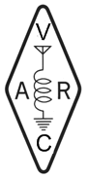
5 – 9 November 2012 Ho Chi Minh City, Viet Nam

Document No. 12/XV/056
Agenda Item: 10.1.20

EXPERIMENT OF NEW MODE
FOR THE CHINESE TEXT EXCHANGE OVER HF BANDS
IN AMATEUR RADIO EMERGENCY COMMUNICATIONS
Chinese Radio Amateur Club, CRAC
Chinese Radio Sports Association, CRSA

Considering that the exchange of accurate text messages is essential to the life rescue and disaster relief, and that the possible critical condition can be met due to poor wave propagation, shorten power and simple antenna at the disaster area, it would be very important to have an practical and easy way to exchange Chinese text message at low signal-noise ratio in amateur radio emergency communication in China.
Since 2011 CRAC is working on a project to experiment such a new mode, and by now has completed the first phase. The mode is named CP-16, standing for Chinese character Pattern of 16 x 16 dot-matrixes.
Normally over 6000 characters are often used in Chinese text and have been collected into a two-byte coding set by the national standard organization; each byte has 7 bits of data while another bit is usually used to separate Chinese byte from ASCII byte. Most of previous popular amateur radio software for data communication do not support such a coding structure, moreover, if a data byte is missing on the path, the two-byte grouping will be shifted and destroyed and thus the rest part of text could be all misinterpreted.
To achieve the goal of allow easy communication at very low S/N ratio, CP-16 is designed to directly transmit the graphic image of Chinese character as a 16 by 16 dot-matrix, one line at a time and about 10 mS per line adjustable according to the condition. This makes the total transmission speed of 2 to 5 characters per second, which is suitable for real-time reading.
CP-16 message can be received by any SDR receiver or the combination of an ordinary SSB receiver and a PC computer, plus any SDR/audio analyzing software with waterfall display. The text will be directly shown on the waterfall graph. The human brain of the Chinese operator will be easily filter out all sorts of noise and correctly pick up the original text from weak signal.
The phase 1 is focused on the experiment of generating CP-16 signal by software and sound card in PC computer, and selecting the best modulation parameters. It is found that 16 on-off –keyed audio carriers with 17Hz apart from each other shall be good enough, the total band width correspondingly needed is just within the range of a 400Hz CW filter, as demonstrated in the lower center of the figure “DX Display” below.

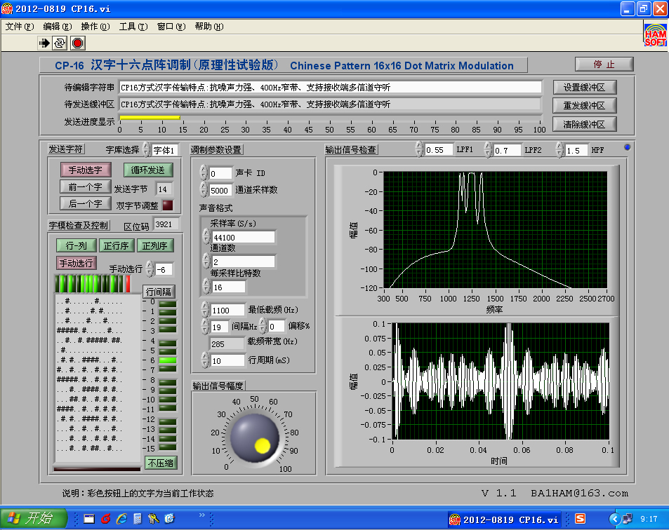 | 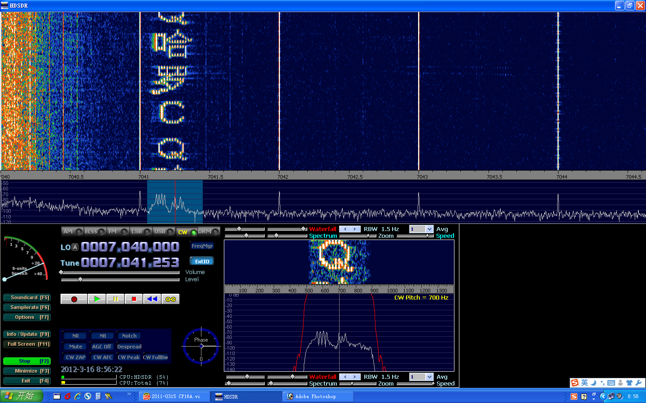
TX Interface | RX Display

The future phase 2 of CP-16 project to pack the modulation function into a small and simple hardware box based on a microprocessor worked as direct digital synthesizer, while still use PC computer as the operating interface. The possible phase 3 would be to program the operating interface for TX and RX into some popular mobile phone handsets and then make them to communicate with the modulation box via Bluetooth or Wi-Fi. If everything is successful through all phases, only a low cost modulation box is to be invested by each HF ham operator, but the power of amateur radio emergency communication could be improved.

____________________

