 | INTERNATIONAL AMATEUR RADIO UNION  REGION 3  fourteenth Regional Conference | 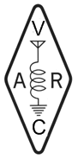
5 – 9 November 2012 Ho Chi Minh City, Viet Nam

Document No. 12/XV/055
Agenda Item: 12.6

THE CRAC STRATEGIES FOR
AMATEUR RADIO EMERGENCY COMMUNICATION IN CHINA
Chinese Radio Amateur Club, CRAC

A review on amateur radio in the recent main disasters in China was made by CRAC. The event being countered covers the Wenchuan earthquake of 2009，killing about 70,000 lives, the Yushu earthquake of 2010, killing more than 2000 lives, and some other earthquakes, landslidings, snow storm attacks, etc. The purpose of the study is to learn the general situation of emergency communications in different disasters scenes in China, and to find the spaces in fatal disasters where amateur radio emergency communication would be mostly needed and might possibly play key roles, and further to set the strategies for CRAC to better be prepared for the future.
The study shows the most important roles that Chinese radio amateurs can play in sudden devastating disasters where normal communications can be destroyed, is to report the situation from the disaster area over HF radio to the disaster control department of the up-level government, normally less than one or up to few hundred kilometers, and to establish the filed VHF/UHF radio network in the disaster area for the self-rescue before any outside professional rescue force arrives.
Consequently, the following strategies are adopted by CRAC.
Strategy One: To continuously promote the growth of ham population in the country
The above roles are based on the condition that there is amateur radio facility survived in the devastating disaster. The probability of the surviving is to be guaranteed by the sufficient number of radio amateurs in any disaster area. It is beyond question that the essential strategy for CRAC is to continuously promote the growth of amateur radio population in the country.
Strategy Two: To create a modern infrastructure to lift up the total power of amateur radio emergency communication
To make the most efficient use of the emergency information transmitted by amateur radio stations from the isolated disaster area, a modern and open amateur radio emergency QSP system is necessary. In such a system the amateur radio link between the disaster field and its contact partner shall be the only radio hop. The rest route for the emergency information go from the initial contacting station to all other group related to rescue and relief shall be direct and immediate. As the national amateur radio organization, CRAC is taking the establishment of the modern infrastructure as own strategic task. The system which merges the amateur radio emergency communication with the modern public communication work is temporarily named by CRAC as Chinese Amateur Radio Emergency Service Network (CARESN).
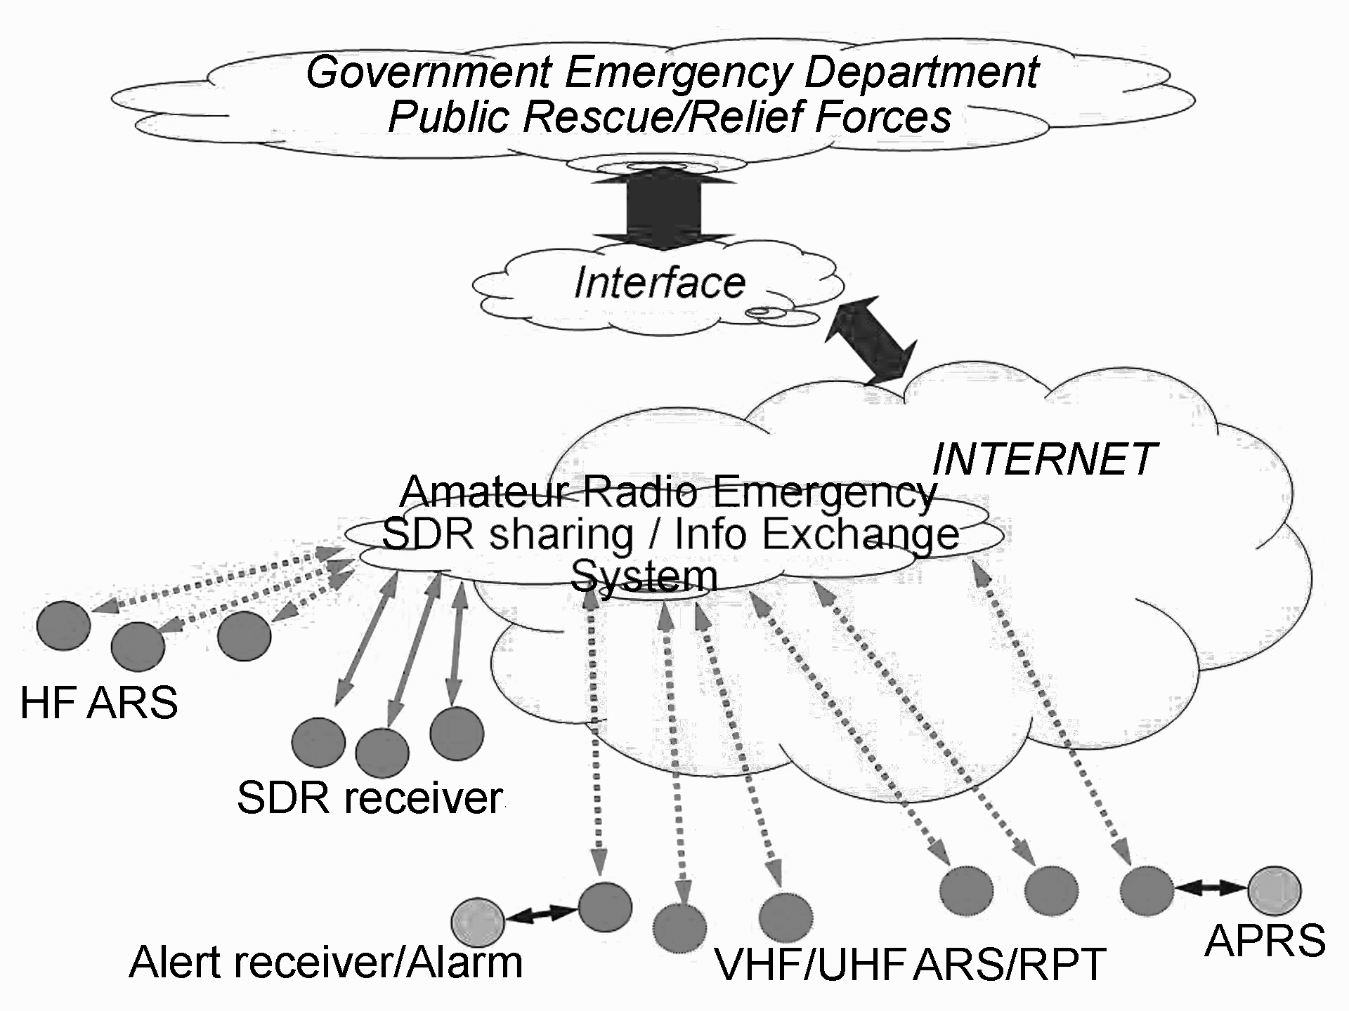
CARSEN

As a part of this long term strategic task, CRAC is now working on create initial blocks of CARSEN, and will build it step by step. The issues being currently considered are as following.
1, Emergency SDR receiver sharing system
A practical problem is many radio amateurs in China live in urban areas with noisy EMI environment, and it is not easy for them to make good copy of possible weak signals from the disaster area. So CRAC is considering to build a nation-wide SDR receiver sharing system via internet, which is somewhat similar to WEBSDR, to make clear and clean signals from several carefully selected receiving sites available to more hams. This will also supply a shortest information path from the HF station at disaster area to any part related on the rescue and relief job, rather than just manually pass the emergency report from one ham to another over multi radio links. At the moment CRAC is making investigations for suitable SDR hardware.
2, New mode of Chinese text communication for critical conditions
The accurate Chinese text message transfer under low signal-to-noise ratio is very important for amateur radio emergency communication on HF band in China. CRAC has started a project since 2011 to experiment such a mode.
3, Automatic emergency alert system
If a disaster occurs in the midnight of a normal working day, most of domestic radio amateurs would be in beds and the emergency HF call from disaster area could be tragically missed. An alert receiver with automatic wake up alarming function would be help. It is expected to detect very weak pre-defund CW or PSK31 alert signal on the emergency calling frequency using DSP technique. CRAC will possibly start the project in the coming years.
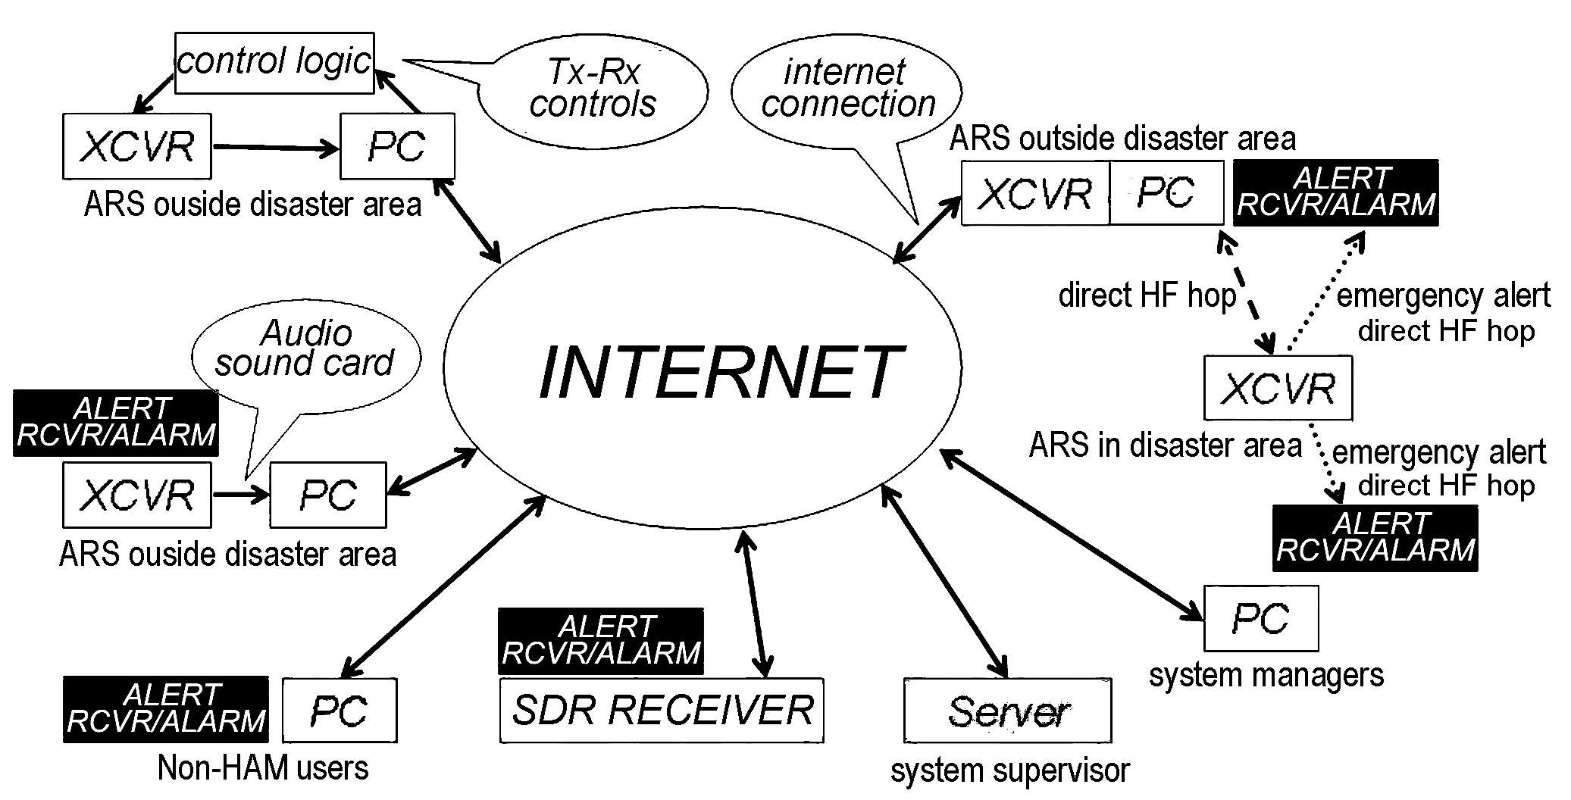
HF section of CARESN
4, Internet access platform for VHF/UHF amateur radio station/repeater
During the disasters radio amateurs in, near by or far from the disaster center are often teamed up to drive to the front field to help rescue forces and other relief organizations in communications. Share their communications with other supporting hams is important. An all-in-one internet access platform for VHF/UHF ham stations and repeaters will be an important sub-system of CARESN system succeedingly. The final goal of this sub-system is to combine the local VHF/UHF amateur radio emergency networks and some dedicated ham Wi-Fi networks in disaster area with all other supporting radio amateurs into a unified information system to maximize the total power of amateur radio via closer cooperation and coordination.
Currently CRAC is working on an initial system with APRS and internet message exchange.

