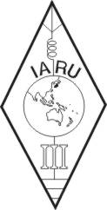 | INTERNATIONAL AMATEUR RADIO UNION  REGION 3  fourteenth Regional Conference | 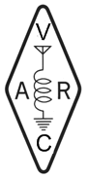
5 – 9 November 2012 Ho Chi Minh City, Viet Nam

Document No. 12/XV/054
Agenda Item: 11.2.1

INFORMATION: CRAC WORKS ON WRC-15 AGENDA 1.14

CRAC is now actively liaison with the Chinese member of WP5A of ITU and the representatives of other domestic radio services related to WRC-15 agenda item 1.4., to express the need from amateur radio for the possible new allocation to the amateur service on the secondary basis in the frequency band 5 250–5 450 kHz. More discussion will be taken with related parties.

____________________

