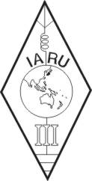 | INTERNATIONAL AMATEUR RADIO UNION  REGION 3  Fifteenth Regional Conference | 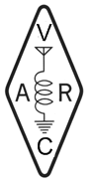
5 – 9 November 2012 Ho Chi Minh City, Viet Nam

Document No. 12/XV/049
Agenda Item: 14

NOTICE of MOTION to propose AMENDMENT of the CONSTITUTION
submitted by WIA

This is to acknowledge the reception of the attached document from WIA, on July 30, 2012.

The attached document provided the Notice of Motion to propose Amendment of the Constitution in accordance with the Clause 56A of Constitution.

____________________

