 | INTERNATIONAL AMATEUR RADIO UNION  REGION 3  Fifteenth Regional Conference | 
5 – 9 November 2012 Ho Chi Minh City, Viet Nam

Document No. 12/XV/043
Agenda Item: 12.6.3

EmcomNet – A High Performance Digital Emergency Communications System
With A Long History

Backgound

Today’s EmcomNet emergency digital communications system has developed from the Australian Red Cross Emergency Communications (RECOM) system, to form a core dedicated 24/7 digital network that can be utilized by a number of amateur emergency communications groups. EmconNet provides specialised HF data modems and specially developed EmcomWin purpose built software package.

Since its inception in 1997 the EmcomNet network node stations has never failed, and operates 24 hours per day 365 days of the years. Over the past 15 years, the RECOM (EcomNet) has been operationally deployed 140 times, including a number of overseas deployments.

History

RECOM was formed in 1997 and quietly built up an enviable list of achievements in technology innovation and activation service during floods, tropical cyclones and bushfires. The organisation was born out of the thoughts of a few visionary radio amateurs and the Red Cross' Victorian Executive Director, Andrew Hilton, who had the foresight to encourage the adoption of state-of-the-art technology.
Due to the importance of the data and traffic, the design and use of a secure digital communications system was seen as imperative. RECOM developed their own suite of sophisticated software and hardware solutions for emergency deployments, whether local, interstate or overseas, based on low-bandwidth digital modes over HF amateur radio.
In fact, voice communication has never been used as the digital system is capable of transferring fully error corrected data at a useful rate when a similar power level voice signal would be totally inaudible. To make the best use of the relatively low-baud rate the data is highly compressed.
The Red Cross has activated RECOM many times over the years. During the disastrous Black Saturday bush fires in 2009 Red Cross deployed RECOM to nine evacuation centers where all communications had been lost. The data and messages from those centers were transmitted by the amateur digital HF system developed by RECOM.
RECOM field stations use an array of EmcomNet Network stations for data/message delivery to clients, the Network Stations acting as digital RF to Internet Gateways. Secure messaging and file transfer (text, spreadsheets, data files and images) between field stations is also possible. The field data is presented to the "customer" via easily accessed web pages and standard email.
Deployed field stations are GPS tracked, all messages and field data GPS tagged, and all computers in the field are remotely time-locked to GPS synchronised clocks located at the EMCOM Network Stations
To satisfy the legal requirement for confidentiality when transmitting personal details of evacuees, and displaced persons, the data is encrypted with the encryption key "rolling" after each transmission interval and time stamped and stored at the sender's and receiver's end for later analysis in the event of any subsequent inquest.

The EmcomNet group is not a first responder in emergencies, but seeks to work with Non Government Organisations (NGO’s) during disaster recovery and assistance when existing communications channels have failed or are heavily congested. The EmcomNet is a zero cost, communications alternative that provides a near real time digital messaging system that meets the needs of these client organisations utilizing the flexibility of spectrum allocations on the Amateur Service and trained volunteer amateur operators, with professional industry backgrounds.

Network Stations

A number of network stations have been added to the system to provide coverage across Australia, particularly to the north and east coasts. The network station in Darwin (VK8AEN) is in the process of being relocated and should be fully operational before the end of this year. The network station (VK4AEN) is currently being planned to be located centrally in the State of Queensland and will be added to the network to provide a better coverage to the northeast and north of Australia and into the Pacific and Asian regions.

EmcomNet Station coverage

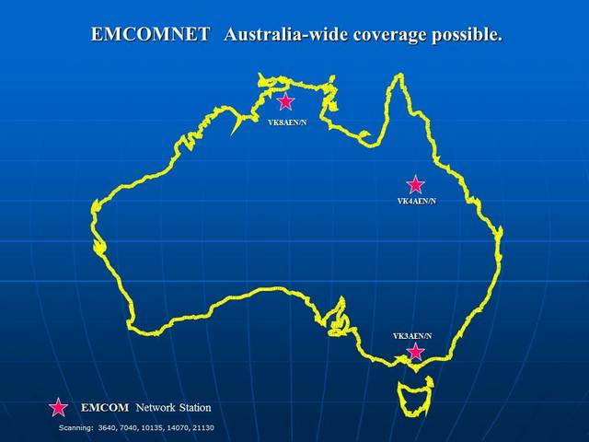

EmcomNet Technical Configuration

The EmcomNet designers are constantly evaluating amateur data systems against a core set of operational requirements. A comparison of various systems is contained in a spreadsheet in Attachment 1.

The EmcomNet system of network and field stations uses the Pactor II modems manufactured by SCS (SCS PTC 11 ) that has redesigned special firmware with enhanced digital signaling processing capability that will generally perform better in weak and noisy environments that the standard Pactor II protocol by a further 3 dB. These changes have been made with SCS endorsement.

A purpose developed software package EmcomWin that operates on a laptop computer running Windows XP or later provides a number of key features:

- Email (no email client required)
- GPS tagged messages direct to a Web page
- Data Encryption (encryption key "rolling" after each transmission)
- Data Compression
- File transfer
- Tracking of GPS equipped stations (field)
- Local mapping of GPS tracked stations
- Channel quality measurements
- Time synchonisation of all stations on the network
- Logging of all transactions (including channel quality)
- Station ID beaconing
- Field stations modems can be re-configured by a network station
Field station equipment use any amateur mobile 100 watt HF transceiver (Icom , Yaesu). Antenna systems depending on the deployment will be tuned dipoles (NVIP), or vertical mounted.

The EmcomNet has access to Ionspheric prediction services on a H24 basis for the geographic area of operation to enhance the operational frequency dynamics.

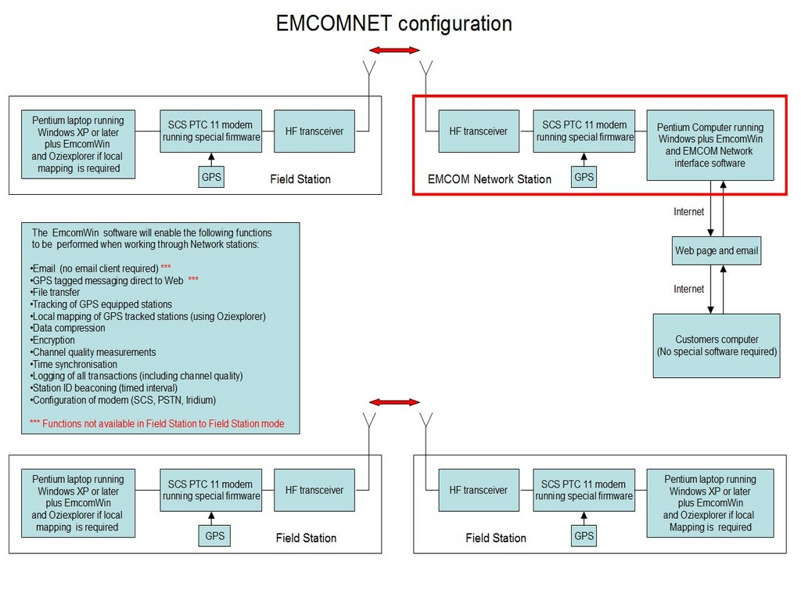

EmcomNet Network Stations

As all network stations are running 24 hours per day, a high degree of reliability is necessary and equipment used is generally of commercial standard.

Scan frequencies: 3640, 7040, 10135, 14070, 21130 kHertz
Scan Interval: 3.6 seconds
Scan dwell time between connects: 60 seconds
Time to scan all channels: 19 seconds
Transceiver type: CODAN NGT (commercial)
Transceiver power output: 100 watts PEP
Antenna: Delta Loop oriented in north/south direction (tuned by SGC 230 Auto tuner)
HF Modem: SCS PTC 11 Pro (running special firmware)
GPS Engine: Trimble A214
Power Supply: Mains via Powerware 9120 UPS
Power backup time: 900 minutes

EmcomNet Membership
For the past 15 years the number of qualified amateurs has varied but has a standing number of 10 amateurs that are prepared to deploy at very short period of notification. Interested competent individuals join the EmComNet Group at the invitation of the group, where those amateurs with a professional industry background, with demonstrated ability in data, HF emergency communications and are prepared to be deployed at short notice. The EmcomNet group owns the SGS modems that are loaned to Ecomnet members. This is to ensure that the modems are always operational, has all the up to date firmware and configured for individual network access.
Rapid Field Deployments
The EmcomNet group has developed the system and equipment features over many years of practical experience. The system is tested each week and all members are expected to participate.
To assist with deployment at short notice, EmcomNet has developed a number (5) rapid “fly kit” that comprises all the essential items of equipment that can be easily transported by aircraft or ship. See photo below. Each operator has their own personal laptop computer loaded with the EcomWin software package.
EmcomNet is available for discussions with NGO’s located in Australia and in Region 3 to explore ways the group can assist in other countries during disaster recovery activities.

EmcomNet Fly Kit
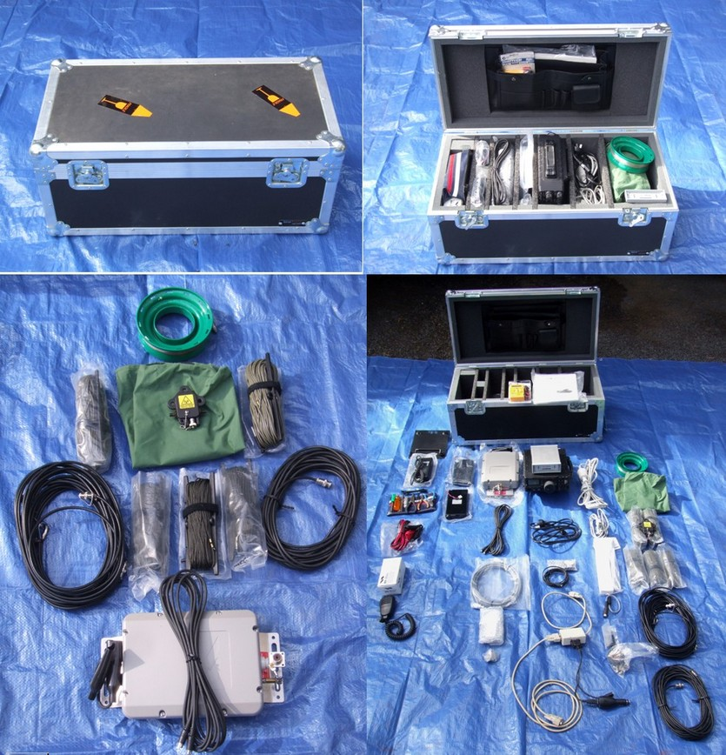

------------------------------------------

Recommendation

That member Societies note the contribution that amateur radio can play in meeting communications needs during time of disasters and relief operations, particularly for non-Government organisations.

It is recommended that the IARU R3 explore ways in which developing countries can benefit from the practical experience of EmcomNet like organisations and foster discussions for bi-lateral arrangements for deployment of EmcomNet personnel on a needs basis.

Attachment 1

Analysis of Operating Modes & Options for Emergency Communications Usage
Note: Two other key service indicators (reliability of provision of the emcom service, and speed of response) are organisational issues, not communication system issues
Mode / Option | Robustness | Security | Accuracy | Throughput | Flexibility | Auditability | Deployability | Relative cost | Comments
Voice Modes
HF | Fair. Requires reasonable S/N ratio (probably about +10 dB S/N) | Poor | Fair. Very prone to human error. | Poor. Transfer of 1/2 page of text can take 30 mins or more | Poor - no ability to transfer data | Fair - dependant on manual logging and scrupulous document control | Good, requires deployment of base station also | low | Can usually (not always) provide comms over extended distances needed for emcom use (50 - 500+ km). Many possible forms of transcription errors. Active frequency management essential. Required S/N about 30 dB higher than best digital mode. Net control under poor conditions very difficult.
VHF / UHF | Good, short range only | Poor | Fair. Very prone to human error. | Poor. Transfer of 1/2 page of text can take 30 mins or more | Poor - no ability to transfer data | Fair - dependant on manual logging and scrupulous document control | Fair. Often requires repeaters. | low | Not suitable for reliable operation beyond a few tens of km. Often requires additional systems (eg repeaters). Many possible forms of transcription errors.
Voice plus phone patch | Fair. Requires reasonable S/N ratio (probably about +10 dB S/N) | Poor | Fair. | Poor | Poor - no ability to transfer data | Poor - depends on manual logging of content | Good, requires deployment of base station also | low | Assessment as for voice. Of very limited value for emcom given Telstra have 600 satphones for deployment to disaster areas.
Digital Modes
VHF packet (unencrypted) | Good, short range only | Poor | Excellent | Good | Good | Trak excellent, otherwise poor | Fair. Often requires repeaters. | low | Not suitable for reliable operation beyond a few tens of km. Often requires additional systems (eg repeaters).
VHF packet (encrypted) | Good, short range only | Potentially excellent. Functionality must be developed. | Excellent | Good | Good | Trak excellent, otherwise poor | Fair. Often requires repeaters. | low | Not suitable for reliable operation beyond a few tens of km. Often requires additional systems (eg repeaters). Encryption must be transparent to the user.
VHF Packet to Winlink2000 (Using RMS Express client) | Good, short range only | Poor. Encryption not permitted on Winlink2000 system. ** | Excellent | Good | Fair. Some file types not permitted. ** | Poor - requires additional functionality | Poor. Often requires repeaters, must have access to gateway station. | low | Not suitable for reliable operation beyond a few tens of km. Often requires additional systems (eg repeaters). Lack of VHF gateway stations.
HF packet | Poor to very poor |  |  | Poor to good |  |  | Good, requires deployment of base station also | low | Otherwise as for VHF packet. Much better modes available.
HF Winmor / Winlink2000 (Using RMS Express client) | Poor to fair. Lack of frequency options with VK gateways, therefore may not have 24/7 HF coverage. | Poor. Encryption not permitted on Winlink2000 system. ** | Excellent | Fair. High overheads. Poor compression. "Bandwidth catastrophe" very difficult to prevent. | Fair. Some file types not permitted. ** | Poor - requires additional functionality | Fair, some issues with lack of gateway stations in VK Also limits on daily onnect time | low | Winmor is a 'sound card' mode with extensive error correction. Winmor claims throughput similar to Pactor2. Experience is that it is nowhere near as robust as Pactor under marginal signal conditions, and Pactor3 is faster when conditions good. Available frequency options (set by gateway stations) restrict ability to provide 24/7 communications.
HF Pactor / Winlink 2000 (Using RMS Express client) | Fair. Lack of frequency options with VK gateways, therefore may not have 24/7 HF coverage | Poor. Encryption not permitted on Winlink2000 system. ** | Excellent | Fair. High overheads. Poor compression. "Bandwidth catastrophe" very difficult to prevent. | Fair. Some file types not permitted. ** | Poor - requires additional functionality | Fair, some issues with lack of gateway stations in VK. Also limits on daily connect time | medium | Pactor performance considerably better than Winmor. Available frequency options (set by gatway stations) restrict ability to provide 24/7 communications. Decodes to -20 dB signal/noise or better (in voice bandwidth).
HF Pactor / EMCOM network (Using EmcomWin) | Very good - many frequency options. Can decode down to -20 dB S/N or better | Excellent - encryption included | Excellent | Good - strongly optimised to maximise throughput with advanced compression and low network overheads. | Good | Excellent - included | Very good, 'base' stations automatic & run 24/7, also extra high capability network stations for activations | medium | Can virtually always provide comms over extended distances needed for emcom use (50 - 500+ km). Decodes to -20 dB signal/noise or better (in voice bandwidth). Frequency management essential.
Other HF digital modes |  |  |  |  |  |  |  |  | All have issues of one kind or another, particularly throughput, error correction (accuracy), etc
Definition of criteria: | Robustness | The ability of the system to provide throughput under all conditions, 24/7/365 |  |  |  |  |  | Key:
 | Security | Whether unauthorised personnel can eavesdrop on information being transmited |  |  |  |  |  |  | Poor. Unacceptable for emcom purposes. Excludes system from consideration.
 | Accuracy | The likelihood that information conveyed through the system can be guaranteed to be 100% accurate |  |  |  |  |  |  | Marginal. Unlikely to achieve client requirements. Not recommended.
 | Throughput | The relative speed of information transfer through the system
 | Flexibility | The ability of the system to handle various forms of information (ie not just text) |  |  |  |  |  |  | Good. Likely to achieve client requirements
 | Auditability | The degree to which the system automatically keeps records of all transactions
 | Deployability | The ease with which the system can be deployed for emergency communications use |  |  |  |  |  |  | Very good to excellent. Will definitely meet client requirements.
** see: http://www.winlink.org/guidelines

