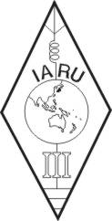 | INTERNATIONAL AMATEUR RADIO UNION  REGION 3  Fifteenth Regional Conference | 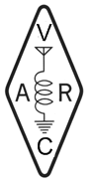
5 – 9 November 2012 Ho Chi Minh City, Viet Nam

Document No. 12/XV/040
Agenda Item: 10.2.6

Report to the 15th IARU Region 3 Conference in November, in Ho Chi Minh City, Viet Nam.

14 September 2012

Number of IARU Region 3 Awards issued:

Year | Basic | Silver | Gold | Total | Comments
2009 | 3 | 10 | 10 | 23
2010 | 16 | 5 | 37 | 58 | 34 were as a result of an IARU 3 stand at Dayton.
2011 | 20 | 12 | 15 | 47 | One Ham received 15 certificates
2012 | 3 | 4 | 12 | 19 | Total for the year till 14 September

Of the three main DX awards that I issue the IARU Region 3 award is still the most popular award.
This has been the case since 2007.
.

Regards

Alan Chapman ZL3GX

IARU Region 3 Award and NZART Awards Manager.

