 | INTERNATIONAL AMATEUR RADIO UNION  REGION 3  Fifteenth Regional Conference | 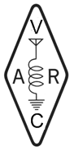
5 – 9 November 2012 Ho Chi Minh City, Viet Nam

Document No. 12/XV/009
Agenda Item: 10.2.1

Report to the 15th IARU Region 3 Conference
Ho Chi Minh City, Viet Nam
November 2012

This report covers the status of the NCDX/IARU International Beacon Network in Region 3.
Status
At the time of writing this report 30th August, 13 of the possible 18 Beacons in 5 bands are fully operational. VK6RBP is the only R3 beacon non-operational, the others are: 4U1UN, 5Z4B, LU4AA, YV5B.

During the period, I, in consultation with others selected 7.0475 MHz as a suitable frequency for a low power beacon requested by Agung Priyo YD0MWK of Indonesia. The beacon details are:
1. an intermittent beacon operating 24 hours a day
2. The Beacon will be automatic; Mode is CW using a homebrew keyer
3. Homebrew transmitter at about 5 Watts output,
4. Antenna is Inverted Vee about 15 metres from the Ground
5. ITU Zone is 54, CQ Zone 28, and LOCATOR being OI33MQ (oi33mq)
6. Beacon Call-sign YD0MWK-I
IBP Beacon Locations
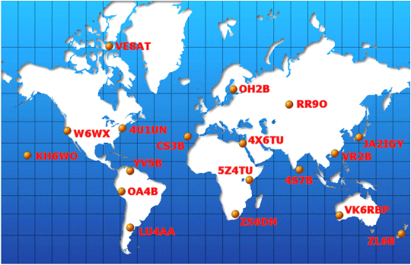

NCDXF/IARU Beacon Transmission Schedule as at June 2012

Call | Location | 14.100 | 18.110 | 21.150 | 24.930 | 28.200 | Operator | Status
4U1UN | United Nations | 00:00 | 00:10 | 00:20 | 00:30 | 00:40 | UNRC | OFF
VE8AT | Canada | 00:10 | 00:20 | 00:30 | 00:40 | 00:50 | RAC/NARC | OK
W6WX | United States | 00:20 | 00:30 | 00:40 | 00:50 | 01:00 | NCDXF | OK
KH6WO | Hawaii | 00:30 | 00:40 | 00:50 | 01:00 | 01:10 | KH6BYU | OK
ZL6B | New Zealand | 00:40 | 00:50 | 01:00 | 01:10 | 01:20 | NZART | OK
VK6RBP | Australia | 00:50 | 01:00 | 01:10 | 01:20 | 01:30 | WIA | OFF
JA2IGY | Japan | 01:00 | 01:10 | 01:20 | 01:30 | 01:40 | JARL | OK
RR9O | Russia | 01:10 | 01:20 | 01:30 | 01:40 | 01:50 | SRR | OK
VR2B | Hong Kong | 01:20 | 01:30 | 01:40 | 01:50 | 02:00 | HARTS | OK
4S7B | Sri Lanka | 01:30 | 01:40 | 01:50 | 02:00 | 02:10 | RSSL | OK
ZS6DN | South Africa | 01:40 | 01:50 | 02:00 | 02:10 | 02:20 | ZS6DN | OK
5Z4B | Kenya | 01:50 | 02:00 | 02:10 | 02:20 | 02:30 | ARSK | OFF
4X6TU | Israel | 02:00 | 02:10 | 02:20 | 02:30 | 02:40 | IARC | ON
OH2B | Finland | 02:10 | 02:20 | 02:30 | 02:40 | 02:50 | SRAL | OK
CS3B | Madeira | 02:20 | 02:30 | 02:40 | 02:50 | 00:00 | ARRM | OK
LU4AA | Argentina | 02:30 | 02:40 | 02:50 | 00:00 | 00:10 | RCA | OFF
OA4B | Peru | 02:40 | 02:50 | 00:00 | 00:10 | 00:20 | RCP | OK
YV5B | Venezuela | 02:50 | 00:00 | 00:10 | 00:20 | 00:30 | RCV | OFF
Beacon Reception reports are available on line; look at IBP Beacons on Twitter.

Peter Norden ZL2SJ

____________________

