 | INTERNATIONAL AMATEUR RADIO UNION  REGION 3  Fifteenth Regional Conference | 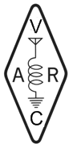
5 – 9 November 2012 Ho Chi Minh City, Viet Nam

Document No. 12/XV/008
Agenda Item: N/A

The International Amateur Radio Union Region 3

A Concise History

