 | INTERNATIONAL AMATEUR RADIO UNION  REGION 3  Fifteenth Regional Conference | 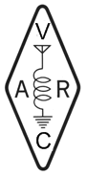
5 – 9 November 2012 Ho Chi Minh City, Viet Nam

Document No. 12/XV/000
Agenda Item: x.x

[TITLE OF THE DOCUMENT]

(Your text here: Please use “Times New Roman” font with size “12”. In case of paragraph heading use Times New Roman in size 12 and “Bold” face. Please indicate the corresponding Agenda Item number above. Please do not change the margins, spacing, and other formatting including headers and footers while writing your documents.)

____________________

