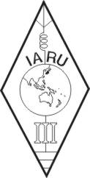 | INTERNATIONAL AMATEUR RADIO UNION  REGION 3  fourteenth Regional Conference | 
12 – 16 October 2009 Christchurch, New Zealand

Document No. 09/XIV/052
Agenda Item: 10.2.7, 11.9

EMR Issues Regarding Amateur Radio

Keith G Malcolm, VK1KM
Region 3 EMR Coordinator

During the year past there has been no activity required or undertaken by the EMR Coordinator.

Survey of the literature dealing with EMR matters shows that there have not been any new developments or issues arising that would affect the amateur community.
____________________

