 | INTERNATIONAL AMATEUR RADIO UNION  REGION 3  fourteenth Regional Conference | 
12 – 16 October 2009 Christchurch, New Zealand

Document No. 09/XIV/042
Agenda Item: 10.2.5, 12.2

Report to the 14th IARU Region 3 Conference
October 2009 Christchurch
New Zealand

Peter Norden, ZL2SJ

This report covers the status and updates of the NCDX/IARU International Beacon Network in Region 3.

Status
I am pleased to report that at the time of writing this report,16 of the possible 18 Beacons in 5 bands are fully operational . All R3 Beacons are operational, RR90 Russia and 4S7B Sri Lanka are non-operational.

IBP Beacon Locations
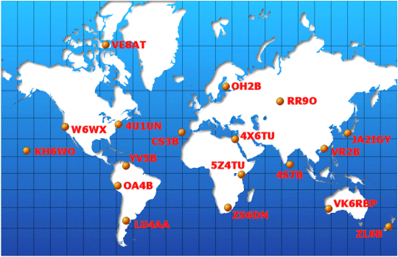

NCDXF/IARU Beacon Transmission Schedule September 2009

Call | Location | 14.100 | 18.110 | 21.150 | 24.930 | 28.200 | Operator | Status
4U1UN | United Nations | 00:00 | 00:10 | 00:20 | 00:30 | 00:40 | UNRC | OK
VE8AT | Canada | 00:10 | 00:20 | 00:30 | 00:40 | 00:50 | RAC/NARC | OK
W6WX | United States | 00:20 | 00:30 | 00:40 | 00:50 | 01:00 | NCDXF | OK
KH6WO | Hawaii | 00:30 | 00:40 | 00:50 | 01:00 | 01:10 | KH6BYU | OK
ZL6B | New Zealand | 00:40 | 00:50 | 01:00 | 01:10 | 01:20 | NZART | OK
VK6RBP | Australia | 00:50 | 01:00 | 01:10 | 01:20 | 01:30 | WIA | OK
JA2IGY | Japan | 01:00 | 01:10 | 01:20 | 01:30 | 01:40 | JARL | OK
RR9O | Russia | 01:10 | 01:20 | 01:30 | 01:40 | 01:50 | SRR | OFF
VR2B | Hong Kong | 01:20 | 01:30 | 01:40 | 01:50 | 02:00 | HARTS | OK
4S7B | Sri Lanka | 01:30 | 01:40 | 01:50 | 02:00 | 02:10 | RSSL | OFF
ZS6DN | South Africa | 01:40 | 01:50 | 02:00 | 02:10 | 02:20 | ZS6DN | OK
5Z4B | Kenya | 01:50 | 02:00 | 02:10 | 02:20 | 02:30 | ARSK | OK
4X6TU | Israel | 02:00 | 02:10 | 02:20 | 02:30 | 02:40 | IARC | OK
OH2B | Finland | 02:10 | 02:20 | 02:30 | 02:40 | 02:50 | SRAL | OK
CS3B | Madeira | 02:20 | 02:30 | 02:40 | 02:50 | 00:00 | ARRM | OK
LU4AA | Argentina | 02:30 | 02:40 | 02:50 | 00:00 | 00:10 | RCA | OK
OA4B | Peru | 02:40 | 02:50 | 00:00 | 00:10 | 00:20 | RCP | OK
YV5B | Venezuela | 02:50 | 00:00 | 00:10 | 00:20 | 00:30 | RCV | OK
Beacon Reception reports are available on line, look at IBP_Beacons on Twitter.
____________________

