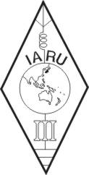 | INTERNATIONAL AMATEUR RADIO UNION  REGION 3  fourteenth Regional Conference | 
12 – 16 October 2009 Christchurch, New Zealand

Document No. 09/XIV/024
Agenda Item: 10.1.13

REPORT FROM ORARI

