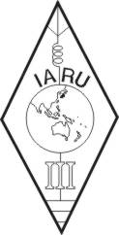 | INTERNATIONAL AMATEUR RADIO UNION  REGION 3  fourteenth Regional Conference | 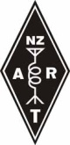
12 – 16 October 2009 Christchurch, New Zealand

Document No. 09/XIV/015
Agenda Item: 11.11

THE NEW ZEALAND AMATEUR RADIO CERTIFICATE OF COMPETENCY AS A JUNIOR TECHNICAL QUALIFICATION

A Paper from the New Zealand Association of Radio Transmitters Incorporated (NZART)

A worthy achievement
Many radio amateurs appreciate that the New Zealand amateur radio qualification, the “Certificate of Competency”, can be regarded as a free-standing junior technical qualification. It is issued by the New Zealand administration, the Radio Spectrum Management Group of the Ministry of Economic Development, as an official government document to candidates who pass the amateur radio examination and who hold a callsign.
The “Certificate of Competency”, is perhaps a useful requisite to support a school-leaver entering the workforce. It shows that the holder has the ability for self-training and it shows self-initiative to study and to perform practical learning outside the established educational system and curriculum.
For convenience we will refer to the “Certificate of Competency” qualification as the amateur radio qualification because it carries both an achievement certificate and the holder’s current callsign(s).
This paper outlines a new project being developed to follow-up and support the “Radio Waves” project, described in another paper.
The amateur radio qualification can be downloaded by its holder from SMART, (“Spectrum Management And Registration Technology”) the administration’s database. It can be printed off in quantity to attach to job applications. It is internationally-recognised. It can hang proudly on any youngster’s wall. And, it is not difficult for a youngster with some independent drive to achieve.
In addition, it is lifelong “ticket” to Amateur Radio, to a lifelong pastime of interest and fun. The potential is limitless.
It is believed that, all other things being equal, that a holder of an amateur radio qualification would get preference over other job applicants at the entry and start of a career.
Getting a job with a future seems to be an increasing concern to some New Zealand families. An amateur radio qualification could open up many surprises.
The subject matter and study requirements for the amateur radio qualification are very wide-based: analogue, digital, solid-state electronics, propagation, wave motion, communication regulations, information techniques, science, satellites, and much more.
The “industry” an amateur radio qualification opens up for possible employment is also very wide – radio, electronics, science, defence, communications, maritime, aeronautical, manufacturing, and much more.
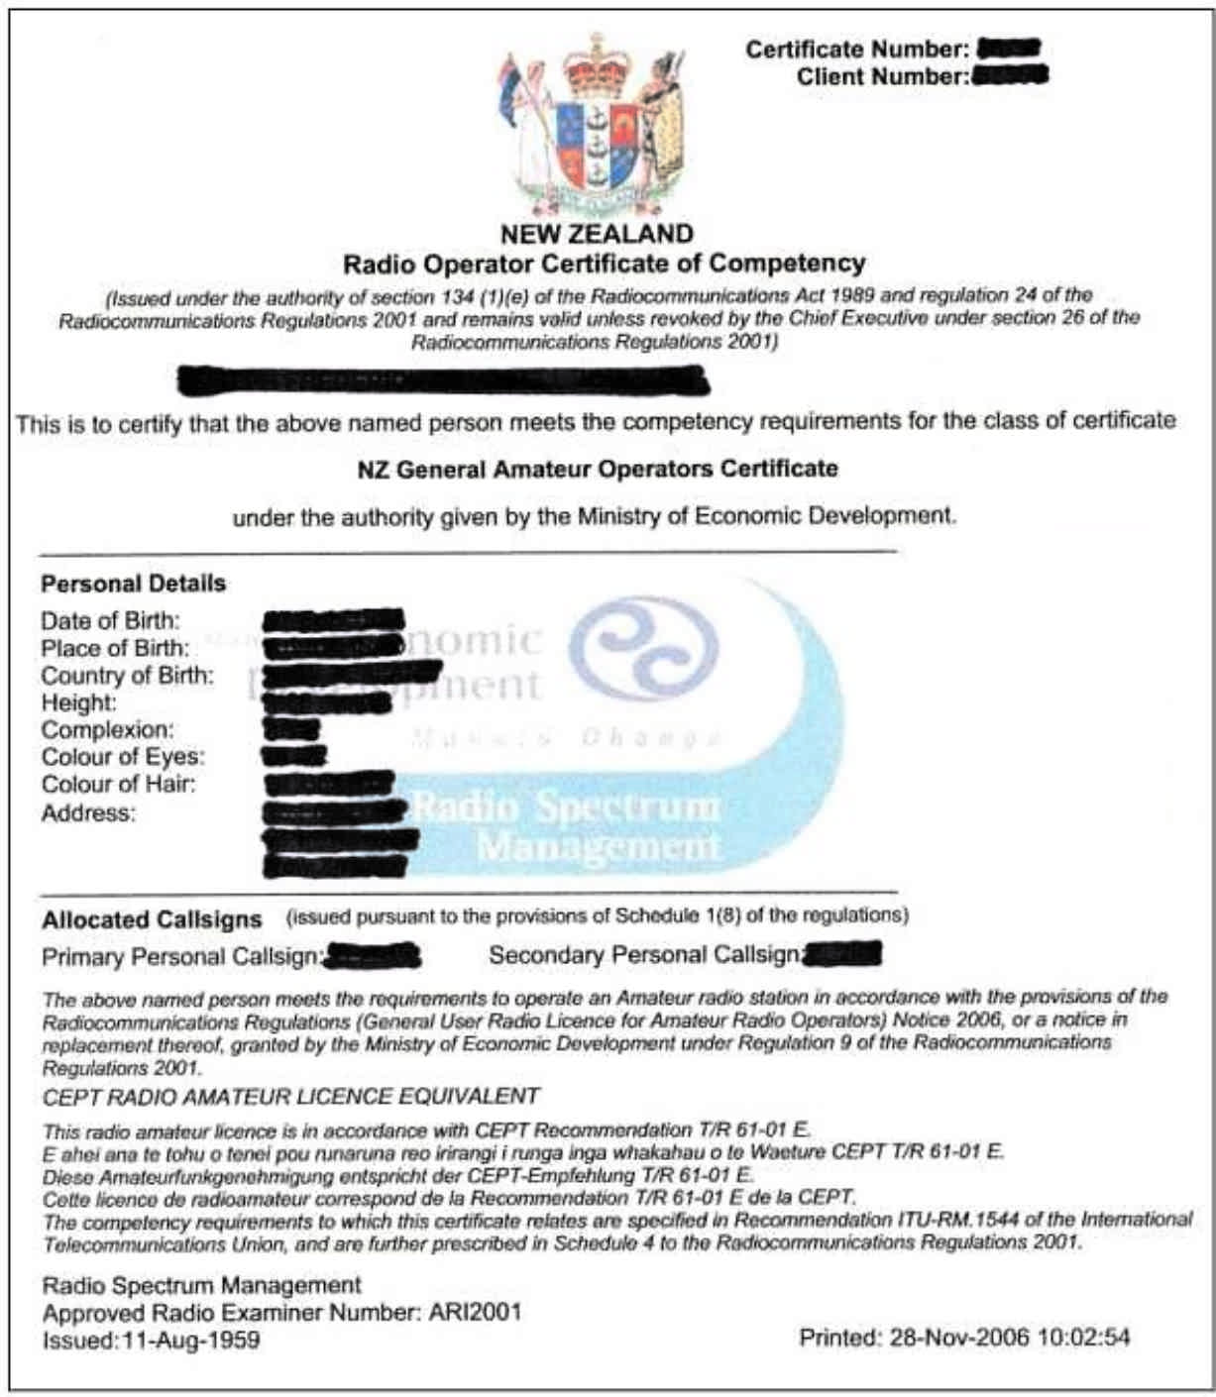
Some “Radio Waves kits” have been manufactured and placed into some schools. “Radio Waves” talks and demonstrations have been presented to school science teachers. Radio amateurs with information about the amateur radio qualification as a junior and independent outside-school-hours achievable qualification of worth could make contact with local schools to advance the opportunities that make it possible to become qualified.
The promotion of the amateur radio qualification supported by classes and other activities could be a positive contribution of NZART Branches to their local communities. This amateur radio qualification approach has been known but has not been adequately promoted in the past.
There is hand-out material on New Zealand web sites to provide all the printed teaching and study notes needed. It is available to anyone, as printed “hand-outs” to students and for the support and guidance of club instructors. The “hard work” has been done. This material has been tested in practice.
A new operating privilege is now available. Using a club callsign with an added suffix, unqualified persons may now take part in “live on-air” operating for practical transmitter experience, under the guidance and supervision of a qualified radio amateur as instructor.
NZART Members are encouraged to establish contact with schools and to provide appropriate information.
Recommendation
That it be noted that:
- The New Zealand amateur radio “Certificate of Competency” can be viewed and promoted as a “junior technical qualification” of worth.
- Radio amateurs and clubs, with information about the amateur radio qualification as a junior and independent outside-school-hours achievable qualification, are encouraged to make contact with local schools to advance the opportunities that make it possible to become qualified.
- Printable hand-out instruction and training notes for the New Zealand examination are at: http://www.vhf.org.nz/pubs/VHFGuide/
- The proposal might be of interest to other IARU societies.
____________________

