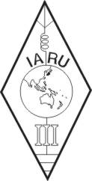 | INTERNATIONAL AMATEUR RADIO UNION  REGION 3  fourteenth Regional Conference | 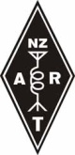
12 – 16 October 2009 Christchurch, New Zealand

Document No. 09/XIV/014
Agenda Item: 11.11

NEW ZEALAND SCHOOLS AND “RADIO WAVES”

A paper from the New Zealand Association of Radio Transmitters Incorporated (NZART)
Introduction
In 1887, in a corner of his laboratory in Berlin, Heinrich Hertz generated and studied electromagnetic waves. Hertz is recognised as being the first to find a means to generate, and the first to study, the physical behaviour of “Maxwell’s waves”. The mathematician James Clerk Maxwell had theorised, a decade or so earlier, that electric and magnetic fields could detach themselves from wires and go free in the form of waves.
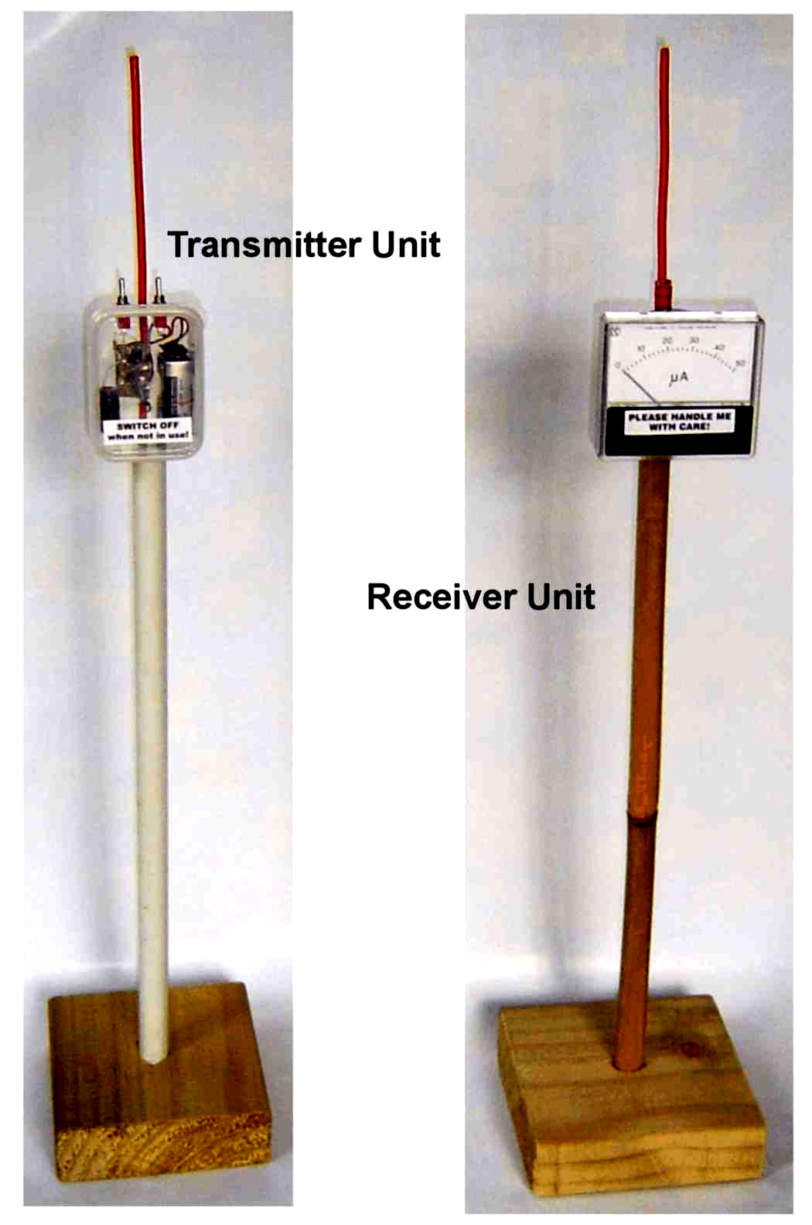
The records show that the first high frequency apparatus used in New Zealand was by Ernest Rutherford when investigating the magnetic characteristics of iron at what was then known as Canterbury University College in Christchurch in 1894. He later worked at Cambridge University, UK. He used a Hertzian spark gap oscillator as an energy source and measured the wavelength of the oscillations with Lecher lines, at frequencies up to 500 MHz. Rutherford later developed a magnetic detector that was adopted by Marconi. So New Zealand has an early history in this field.
Hertz and Rutherford used a spark gap as a device to generate waves and these could be received by observing a spark. The noise of the spark and the smell of ozone in the labs must have been significant.
Today we can easily generate an electromagnetic wave in the classroom to examine the launching of a wave, its propagation through various materials and we can investigate the relative intensity of the signal. It is easy to show how parasitic elements can be used to form a Yagi antenna to extend a radio link. We can show how modulating our signal can convey information over our link. We have complete proprietorship, from the generation of the signal through to the end use, complete control over our experiment. The gear used is simple and cheap and suitable for home-construction.
The “Radio Waves Demonstration Apparatus” is described in a series of booklets that can be downloaded by anyone from the NZART website at: http://www.nzart.org.nz/nzart/waves/radiowaves.html.
This project-in-schools is a long-term one and it continues to evolve. It has been developed to specifically support the teaching of radio in schools. The “radio” component of the official physics teaching syllabus is usually a short session late in the teaching year so the usual window of opportunity for exposure of the equipment to students is short. This has been accepted from the very beginning. The gear is now in the laboratories of many schools and a “second phase” is emerging with schools asking for more details and for demonstrations about Amateur Radio. The seed has been planted and results are slowly beginning to show.
Talks and demonstrations were given to staff of physics departments at university venues at Auckland, Wellington, Christchurch and Dunedin during the year 2007. The universities have an interest in encouraging school students to take an interest in physics and have been very supportive of this project.
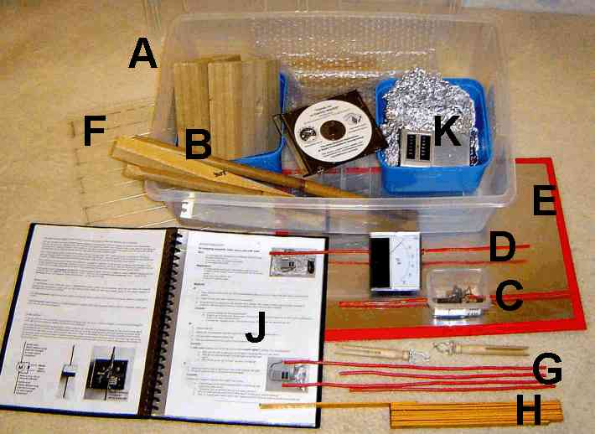
The universities have provided the opportunity and venues for talks and demonstrations at evening sessions for science teachers from their nearby schools. It is estimated that more than 100 school science teachers have now seen the “Waves” equipment demonstrated. The equipment has also been demonstrated with formal papers presented at several physics “seminars” held at university venues.
The Physics Department of the University of Canterbury asked for 37 already-assembled kits of the Radio Waves equipment to distribute to their local schools. The Manawatu Amateur Radio Society, NZART Branch 20, ordered ten kits. These ten kits were donated by Branch 20 to Te Manawa, (http://www.temanawa.co.nz) the museum, gallery and science centre at Palmerston North, to be used for teaching radio-wave related topics in schools.
A “kit” is a collection of the essential parts needed to generate and to receive a radio wave in a classroom and to examine its characteristics. A complete radio link is set up for inspection and has an elementary modulation facility to show how information can be transmitted.
The contents shown in the photograph are:
A. The transit case to carry the complete kit, with accessories including a spare battery.
B. Base blocks and stands for the transmitter and receiver.
C. The transmitter – for the no-licence-required 433 MHz ISM band.
D. The receiver unit.
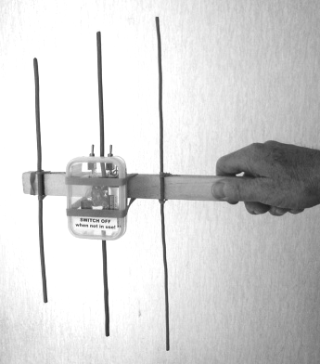
E. The metal “reflector plate”.
F. The wave “grating”, a transparent plastic sheet fitted with parallel conductors (difficult to photograph).
G. Two booms (plastic rulers), with wires and rubber bands for quickly fabricating yagi-uda antennas using the transmitter and receiver units.
H. A measuring ruler.
J. The Instruction Manual.
K. Storage for the current NZART Training CD-ROM, two plastic bags (transparent and opaque) and aluminium foil. Other items for other radio experiments are also stored here.
The original prototype kit was donated to the Hutt International Boys’ School in Upper Hutt. So forty-eight “Radio Waves” demonstration kits are now distributed to educational establishments.
The kits have been constructed with support and assistance from the Wellington VHF Group, NZART Branch 74. The Branch itself owns three kits which are available for short-term loan at no charge.
During a recent course of instruction for the Amateur Radio Certificate run by the Wellington VHF Group, a kit was used in the classroom to introduce students to the radio wave. This was supplemented with a “Lecher Line” display. Comments from the students gave enthusiastic support for the use of this demonstration gear in future courses.
The box containing the kit has several vinyl labels attached. These labels provide web URL’s to promote Amateur Radio, NZART, the NZART Radioscience Education Trust, and to identify the Wellington VHF Group as the source of the kit. The names of the major organisations that sponsored the kits are also displayed. A CD-ROM provided inside the kit is another Amateur Radio promotion item.
Many young eyes will view these labels in the course of a year. It is important that the URL of the NZART Radioscience Education Trust be listed too because it is a source of prizes and other support for the annual school science fairs.
Recommendation:
That this conference notes:
- That NZART has an active project to support “Radio Wave” experiments in schools and for the promotion for Amateur Radio.
- That a web site provides full information:
http://www.nzart.org.nz/nzart/waves/radiowaves.html.
____________________

