February 16 - 20, 2004 Taipei, Taiwan

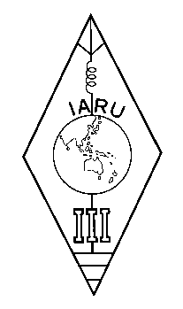 | INTERNATIONAL AMATEUR RADIO UNION  REGION 3  Twelfth Regional Conference | 

Document No. 04/XII/064
Agenda Item: 6

INVITATION
TO HOLD THE 13TH IARU REGION 3 CONFERENCE
IN INDIA
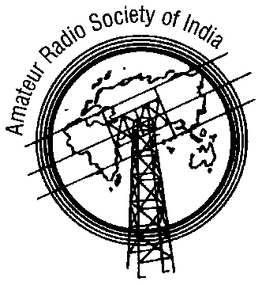
AMATEUR RADIO SOCIETY OF INDIA
(Affiliated to IARU)
# 488, 14-Main, 3-Block, Koramangala, BANGALORE-560034, INDIA
Email: rcr@vsnl.com Phone: +91-80-5536853

INVITATION TO HOLD THE 13TH IARU REGION 3 CONFERENCE
IN INDIA

ARSI would like to host the 13th IARU Region 3 conference in Bangalore India. So far India has not hosted this conference. If the chance is given to us this time we will be honored and it will be a great moral booster to the Ham population of India.

Bangalore is the fifth largest city in India and has all the facilities needed to hold such conferences. We have direct Air links with many South East Asian countries. We also have one of the largest population of Hams in India.

I would like to elaborate more on this subject when the matter comes up for discussion before the venue is decided.

Chandru
VU2RCR
President ARSI
____________________

