February 16 - 20, 2004 Taipei, Taiwan

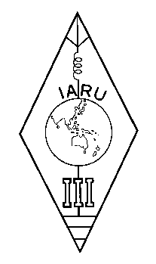 | INTERNATIONAL AMATEUR RADIO UNION  REGION 3  Twelfth Regional Conference | 

Document No. 04/XII/059
Agenda Item: 12.4

Proposal on Further Promote ARDF

Among IARU Region 3 Member Societies
Chinese Radio Sports Association

Noted:
Amateur radio direction finding has been welcome by radio amateurs in many Region 3 member societies such as BARL, CTARL, JARL, KARL, MARTS, NZART, PARA, RAST, WIA and CRSA. It plays active roles in attracting youngsters into amateur radio community;

Noted:
The requirement in intensive long distance running of current Region 3 ARDF rules adopted at 9th IARU R3 Conference in 1994 well reflects the highest physical fitness of radio amateurs in the higher latitude area, but discourages the further widen of common ARDF family into more member societies of the region, especially those in tropical area;

Recognizing:
A set of new ARDF rules, which better and more widely fit the specific conditions and the interest of radio amateurs in this region, is necessary for further promoting in both international and domestic ARDF activities as a guideline parallel with the existing rules;

Propose:
1, IARU Region 3 take a strategic view to ARDF that it is not only a game of elite, but also a good way of introduce and spreading amateur radio;

2, IARU Region 3 shall put the task of establishing a set of new Region 3 ARDF rules in action;

3, To encourage any efforts from member societies in developing radio direction finding activities, IARU Region 3 shall set up a clear official definition of the term ARDF, that is:
Amateur Radio Direction Finding is referred to all kind of training, researching, contesting or other activities based on the technique of radio direction finding, which are carried out or conducted by licensed radio amateurs on the frequencies allocated to amateur service.
____________________

