February 16 - 20, 2004 Taipei, Taiwan

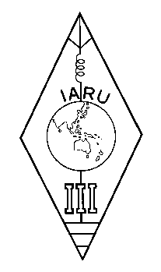 | INTERNATIONAL AMATEUR RADIO UNION  REGION 3  Twelfth Regional Conference | 

Document No. 04/XII/058
Agenda Item: 11.12

The Requirement
IN Morse Code PROFICIENCY
for Amateur Radio Operator’s Certificate

Chinese Radio Sports Association

The current standard for amateur radio operator qualification in the mainland of China was adopted since the end of 2001. The requirement in Morse code proficiency is as following:

Class | Brief Description | Morse Required
Class | Brief Description | Copy | Send
4 | VHF/UHF + small portion on 10m | No | No
3 | Limited HF / 25W | No | No
3 | Limited HF / 25W | No | No
3 | Limited HF / 25W | 5 WPM | No
2 | Full FREQ / 100W | 5 WPM | No
1 | Full FREQ / 1000W | 5 WPM | 5 WPM

There are three available paths to class 3, selectable by applicant: Pass examination including copying international phonetic voice code for those who have some English, pass examination Including copying 5 WPM Morse code for those who have no English at all, or up grade from class 4 by showing 10 QSL cards.

Via this scheme a newcomer can obtain non-code license for entry level HF operation, so that Morse code is no longer a big problem of discouraging newcomers to HF band.

However, the decision of whether and when the requirement in Morse code for high classes operation shall be waived is still under study.
____________________

