February 16 - 20, 2004 Taipei, Taiwan

 | INTERNATIONAL AMATEUR RADIO UNION  REGION 3  Twelfth Regional Conference | 

Document No. 04/XII/057
Agenda Item: 11.11

The Current STATUS of Amateur radio
in the mainland of China

Chinese Radio Sportas Association

General View
The amateur radio population in the mainland of China is still on a low level, however its growth is accelerated since last Region 3 Conference.
By regulations, an operator must apply for an “Operator’s Certificate” from CRSA by passing examination for any transmitting activities, and apply for a “Station License” from Ministry of Information Industry by equipment inspection for the transmitter to be used.
The following two graphs may give a glance to the trends of the number of new operator’s certificate holders and station license holders registered in each year.
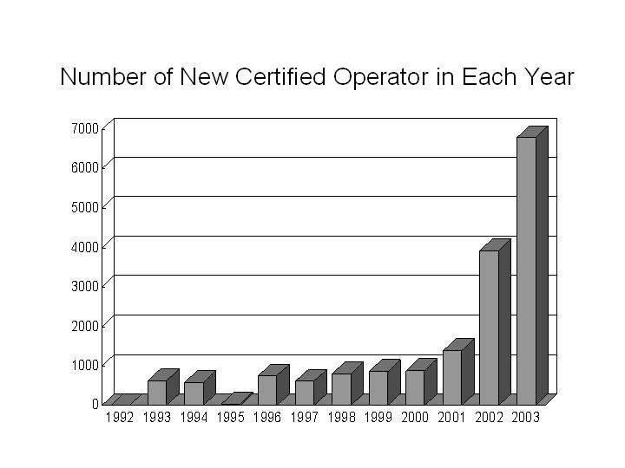
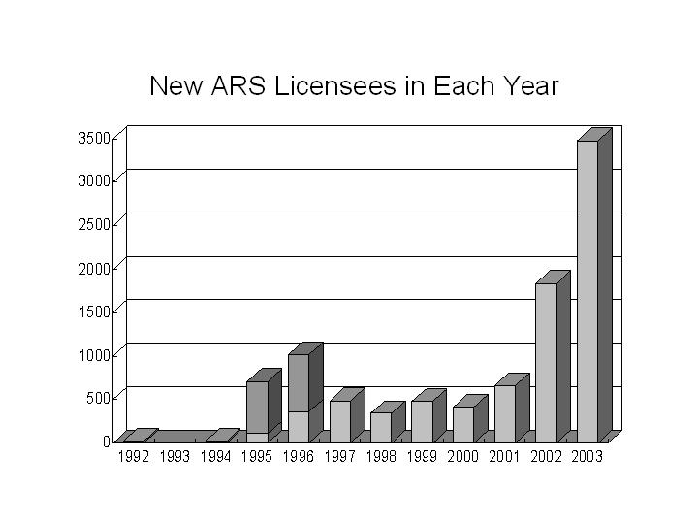

A Space For Amateur Radio To Grow
In spite more people are rush towards internet and international telecommunication is no long miracle, the recent fast expanding of amateur radio population indicates that there is still a space for amateur radio in the mainland of China to grow.

Driven Power from Economy Boost
An important driven power behind the booming is the economy growth of China. A commercial hand-held VHF transceiver was not affordable for most radio amateurs 10 years ago, but nowadays modern transceiver are no long a luxurious dream for many young newcomers.

Encouragement from new qualification system
Adoption of new requirement in amateur radio licensing examination is another key factor in encourage the booming.
Proposed by CRSA, a new regulation in amateur radio operator classification and qualification was adopted since the end of 2001. The simplified procedure for class 4 examination greatly helps newcomers from remote towns and villages, and the multi-path-approach to class 3 gives great flexibility to both Morse code lovers and no code operators.

Spreading By Internet And Mass Media
Another key factor in the booming is the wider spreading of knowledge about amateur radio.
The individual amateur radio activity had paused for a long time, this has made very few have heard about amateur radio.
During the recent years, internet has played very positive role in fill the knowledge gap and spread amateur radio in China.
As estimated, more than 50% of new radio amateurs were sparked by over 100 domestic websites, mailing lists or on-line forums dedicated to amateur radio.

Age And Education Background Analysis
The following graph illustrates the age (year of birth) distribution of CRSA members, including active and passive.
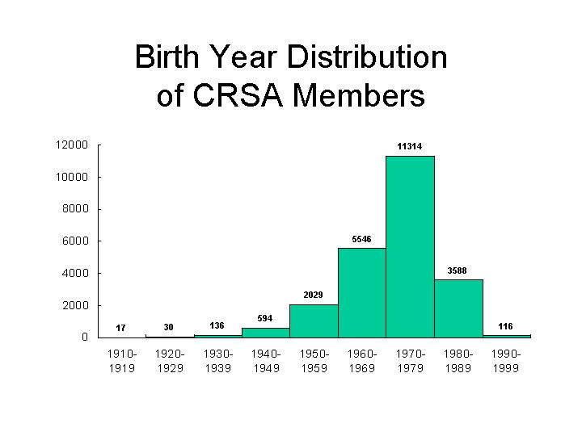
The following Graph illustrates the distribution of education background of CRSA members.
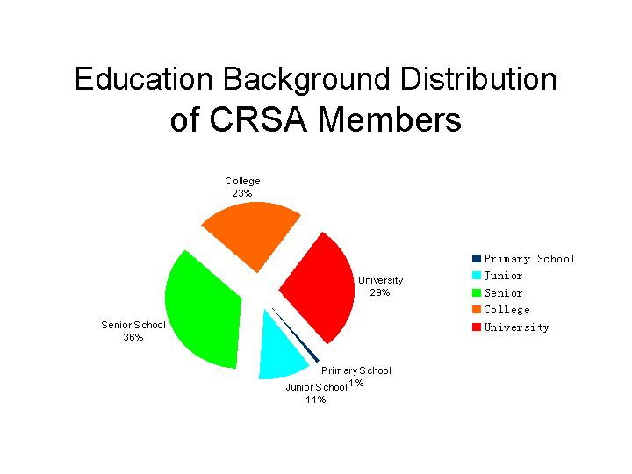
The above charts show almost half of existing and potential radio amateurs are in the age section of 24-33, and about half were educated from colleges or universities.
The conclusion of this analysis is our amateur radio community is much younger than of some well developed Countries. CRSA must study the characters of young generations, and find all possible models of modern radio amateurs.
The pace of life is getting quicker, the knowledge of radio is getting wider, the market is changing greatly that to buy a single resistor or capacitor is becoming a much more difficult job than to buy a transceiver. All of these on-going changing conditions would make some new characters of the new generation radio amateurs. CRSA must properly set her mission to meet the interest of the new generation.

On Going Training
The rushed-in newcomers, the population of which takes obvious advantages over experienced radio amateurs, have brought a heavy on-going training task to CRSA.
So that different types of training are organized locally, such as lectures on radio regulations and QSO rules, field-day alike ARES practices, seminar on specific technical topics, etc.

Gender Analysis
The pie chart below shows the females in only a small part of total existing and potential radio amateurs.
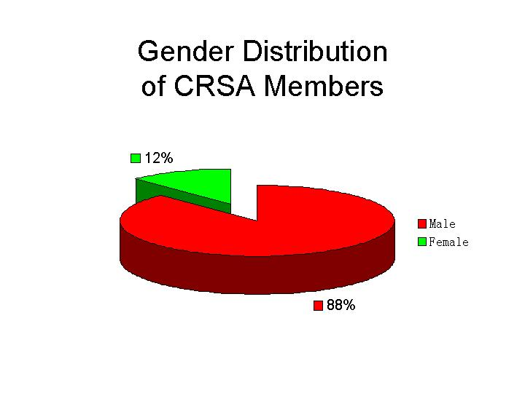

Conclusion
1, Amateur radio in the main land of China is still under developed;
2, So that it still has space to develop and it is developing with its highest speed than ever;
3, It is important for CRSA to study all changing factors and make good policies and decisions to encourage the future development;
4, Learning and training is an important task for the young team of radio amateurs in the mainland of China.
____________________

