February 16 - 20, 2004 Taipei, Taiwan

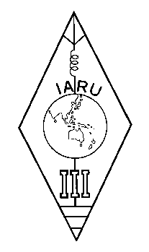 | INTERNATIONAL AMATEUR RADIO UNION  REGION 3  Twelfth Regional Conference | 

Document No. 04/XII/056
Agenda Item: 11.3.6

IARU A.C. Policy #5 (2001, Revised 2003)

A paper from the Secretary

I submit the following Policy #5 (2001, Revised 2003) of the IARU AC to the Conference for consideration.

POLICY #5 (2001, Revised 2003)
concerning guidelines for the election of IARU President and Vice President
1. No later than 12 months, and preferably between 18 and 14 months, prior to the expiration of the term of office of the President then in office, the International Secretariat shall initiate discussions with the Administrative Council to identify suitably qualified candidates available to serve as President. If a member of the Administrative Council is the subject of such discussion, he or she may be asked to withdraw from the meeting during that portion of the discussions.
2. The purpose of these discussions shall be to assemble a list of available candidates who the International Secretariat and the Administrative Council agree are suitably qualified, do not have professional interests that conflict with the objectives of the IARU, and who, prior to taking office, will relinquish any elected position with a regional organization. The list shall be completed no later than 10 months prior to the end of the current term. The International Secretariat shall immediately notify the Regional Organization of any proposed candidate or candidates that have not been designated as a candidate by the appropriate Regional Organization. The International Secretariat shall immediately consult with the appropriate Regional Organization as to that person’s qualifications to serve as an IARU officer.
3. No later than the meeting of the Administrative Council immediately following the completion of the list and after due consideration, the International Secretariat shall select its nominee from the list of candidates and shall advise the Administrative Council of its selection together with supporting material.
4. The International Secretariat shall be invited to this meeting of the Administrative Council to present its nomination.
5. The same procedure shall be used in the case of the Vice President.
____________________

