February 16 - 20, 2004 Taipei, Taiwan

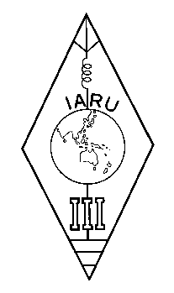 | INTERNATIONAL AMATEUR RADIO UNION  REGION 3  Twelfth Regional Conference | 

Document No. 04/XII/055
Agenda Item: 11.3.5

IARU A.C. Policy #4 (1995, Revised 2001)

A paper from the Secretary

I submit the following Policy #4 (1995, Revised 2003) of the IARU AC to the Conference for consideration.

Policy #4 (1995, Revised 2001)
concerning Administrative Council voting procedures by electronic mail
A procedure for voting by electronic mail is adopted as follows:
If in his opinion a matter requires a decision by the Administrative Council between scheduled meetings, the President shall instruct the Secretary to circulate an explanation and a specific proposal to the members of the Council via electronic mail requesting a return receipt. Affirmation by a majority of the Administrative Council members is required for adoption, including in the majority at least one representative of each region.
The timetable of voting shall be:
Day 1: | President instructs Secretary
Day 2: | Electronic ballots issued
Days 3-14: | Consultation among members if desired
Day 15: | Result announced
The Secretary may announce the result earlier if all members have been heard from.

____________________

