February 16 - 20, 2004 Taipei, Taiwan

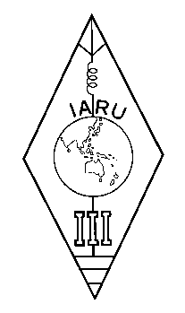 | INTERNATIONAL AMATEUR RADIO UNION  REGION 3  Twelfth Regional Conference | 

Document No. 04/XII/053
Agenda Item: 11.3.3

IARU Resolution 02-2

A paper from the Secretary

I submit the following Resolution 02-2 of the IARU AC to the Conference for consideration

RESOLUTION 02-2
concerning the theme for World Amateur Radio Day 2003
The IARU Administrative Council, San Marino, November 2002,
noting that World Amateur Radio Day is celebrated annually on 18 April, the anniversary of the founding of IARU;
recognizing the need for an annual focus on Amateur Radio and the benefits countries and communications derive from the service;
further recognizing that a fundamental objective of the IARU is to provide opportunities in the exciting technological field of Amateur Radio,
resolves to declare the theme for World Amateur Radio Day 2003 to be:
"Amateur Radio supporting technology education in the classroom."
____________________

