February 16 - 20, 2004 Taipei, Taiwan

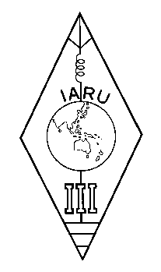 | INTERNATIONAL AMATEUR RADIO UNION  REGION 3  Twelfth Regional Conference | 

Document No. 04/XII/052
Agenda Item: 11.3.2

IARU Resolution 02-1

A Paper from the Secretary

I submit the following Resolution 02-1 of the IARU AC to the Conference for consideration.

RESOLUTION 02-1
concerning potential interference from power line communications
The IARU Administrative Council, San Marino, November 2002,
recognizing the growing use of power lines for high speed data communications;
concerned that radiation from power line communications has a potential for interference with amateur radio reception;
mindful that typical radiation levels potentially interfere with receivers locally and higher radiation levels propagated by sky wave could raise regional noise levels;
aware that scientific investigations are underway in the ITU, CISPR and certain administrations,
recognizing the importance of the Amateur Service remaining informed of developments in this field,
resolves 1. to urge member-societies to recognize the importance of these scientific investigations;
2. to request member-societies to forward published information on these investigations in their own country promptly to the International Secretariat; and
3. to make available copies of relevant documents to any member-society upon request
____________________

