February 16 - 20, 2004 Taipei, Taiwan

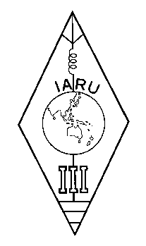 | INTERNATIONAL AMATEUR RADIO UNION  REGION 3  Twelfth Regional Conference | 

Document No. 04/XII/051
Agenda Item: 11.3.1

IARU Resolution 01-1 (Revised 2003)

A paper from the Secretary

I submit the following Resolution 01-1 (Revised 2003) of the IARU AC to the Conference for consideration.

RESOLUTION 01-1
(Revised 2003)
concerning the Morse code
The IARU Administrative Council, Guatemala City, October 2001,
considering the approval without opposition of Recommendation ITU-R M.1544, which sets out the minimum qualifications of radio amateurs,
recognizing that the Morse code continues to be an effective and efficient mode of communication used by many thousands of radio amateurs, but
further recognizing that the position of Morse as a qualifying criterion for an HF amateur license is no longer relevant to the healthy future of amateur radio,
resolves that
IARU policy is to support the removal of Morse code testing as a requirement for an amateur license to operate on frequencies below 30 MHz.
____________________

