February 16 - 20, 2004 Taipei, Taiwan

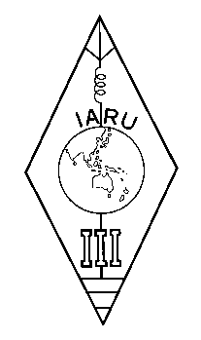 | INTERNATIONAL AMATEUR RADIO UNION  REGION 3  Twelfth Regional Conference | 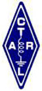

Document No. 04/XII/033
Agenda Item: 11.12

Proposal to the 12th IARU Region 3 Conference
The Pitcairn Island Amateur Radio Association (PIARA)

Background
The American Samoa Amateur Radio Association (ASARA) is formally requesting admission to the International Amateur Radio Union (IARU) and its regional organization, the IARU Region 3, as a Member-Society representing American Samoa. The current Member-Society representing American Samoa is physically nearly 7,000 miles away and in Region 2 of the IARU. The failure to promote Amateur Radio or train new Amateur Radio Operators in American Samoa is considered proof of the need for a local organization. The Society representing American Samoa now has not performed and must be replaced by this local organization.

The American Samoa Amateur Radio Association (ASARA) should become one of our member societies in the same manner as The Pitcairn Island Amateur Radio Association (PIARA) was admitted to be a Member-Society of IARU and IARU Region 3. We believe that the admission of the American Samoa Amateur Radio Association (ASARA) as a Member-Society supports the goals of the IARU for growth and training in Amateur Radio. The growth in numbers of Member-Societies of the IARU not only provides better representation of the represented Amateur Radio Operators but also strengthens the IARU and increases influence in the ITU proceedings. This supports our goal to protect the Frequency Allocations for the Amateur Services. More Member-Societies means more influence and with the threat of digital service interference (i.e. Broadband over Power Lines, BPL) and digital services take over of amateur frequencies, more influence is required.

The Pitcairn Island Amateur Radio Association (PIARA) strongly supports the ASARA application for membership in the IARU and the IARU Region 3 because we share a common purpose. We are both representing small Pacific Islands with a desire to promote future amateur radio growth in THIS Region instead of allowing the former home country colonial rule to continue. We are best able to represent our own island people through daily and personal contact with the people being represented.

The Pitcairn Island Amateur Radio Association (PIARA) strongly recommends that The American Samoa Amateur Radio Association (ASARA) that has been officially organized to better train and represent Amateur Radio Operators in American Samoa, be admitted as a Member-Society of the IARU and the IARU Region 3.

Proposal
The Pitcairn Island Amateur Radio Association (PIARA) proposes that the 12th IARU Region 3 Conference:
instructs the Directors of IARU Region 3
to forward the application for membership in IARU and IARU Region 3, received from the American Samoa Amateur Radio Association (ASARA), to the Administrative Council of the IARU for its review, as soon as possible.
____________________

