February 16 - 20, 2004 Taipei, Taiwan

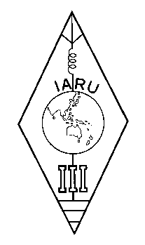 | INTERNATIONAL AMATEUR RADIO UNION  REGION 3  Twelfth Regional Conference | 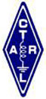

Document No. 04/XII/030
Agenda Item: 11.8, 11.12

Study Proposals for the 2004 IARU Region 3 Conference
at Taiwan by Korean Amateur Radio League

1. Determinations of permissible levels of possible radio interference to the HF amateur radio stations from the PLC (Power Line Communications)

1.1 PLC is proposed to be used worldwide in the near future, and many tests & evaluations of PLC devices are underway in many countries such as Korea, U. S. A. Germany, Japan, etc.

1.2 PLC technologies require higher speed and it results EMI emissions not only via the radiations but also the conductions through the power lines.
Digital streams of unwanted signals from PLC will possibly interfere harmfuly to the HF receivers especially around 30 MHz band.

1.3 Test and evaluations must be carried on by the following two steps.

1.3.1 T & E with laboratory quality test equipments
1.3.2 Subject to the success of 1.4.1, operational test under most probable conditions of amateur operations.
1.3.3 Test result should be open to the public for any comments.

Goals : Permissible levels, Test method, Test procedures, etc.

2. Study of an appropriate protection levels of EMI from the digital HF broadcastings to the adjacent HF amateur radio stations

2.1. Digital HF broadcastings is going to be popular worldwide soon in service.

2.2. Determination of permissible levels of possible radio interference to the HF amateur radio stations from the digital HF broadcastings are essential, especially to the adjacent HF amateur frequencies.
____________________

