February 16 - 20, 2004 Taipei, Taiwan

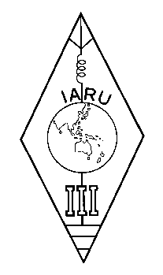 | INTERNATIONAL AMATEUR RADIO UNION  REGION 3  Twelfth Regional Conference | 

Document No. 04/XII/016
Agenda Item: 12.5

The IARU Region 3 Award

A Paper from the New Zealand Association of Radio Transmitters Incorporated (NZART)
for Presentation at the 12th IARU Region 3 Conference Taipei, Taiwan, February 2004

Introduction
The NZART Awards Manager, Alan Chapman ZL3GX, has administered both NZART and the IARU Region 3 Awards from November 1997. Since that time 300 IARU Region 3 Awards have been issued. Applications for this and other awards have been slowing down. Each time details of an award are published in a club magazine it is always followed by an increase in applications.

The IARU Region 3 Award
The statistics for the IARU Region 3 awards issued over this period are:
Calendar Year | Awards Issued
1997 | 76
1998 | 46
1999 | 50
2000 | 60
2001 | 40
2002 | 26
2003(up until 4 March) | 2

The majority of the applications came from Japan and Europe. Of the 300 awards issued, 75 received a Silver sticker and 136 a Gold sticker.
The Award Certificates have now been reprinted without the name and call sign details. This individual information is now printed as each certificate is issued. With advances in desktop publishing, this new procedure produces a much higher quality certificate.

Recommendations
That:
- Region 3 note the continuing, but declining, popularity of the IARU Region 3 Award
- Region 3 Societies continue their publicity about the Award to ensure its ongoing success and to increase awareness of IARU and Region 3
- Participants be made aware of Log sheets and Rules for the IARU Region 3 Award available from the NZART web site www.nzart.org.nz/nzart/awards/awards.html
____________________

