February 16 - 20, 2004 Taipei, Taiwan

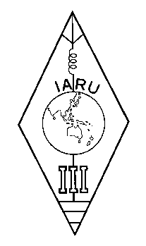 | INTERNATIONAL AMATEUR RADIO UNION  REGION 3  Twelfth Regional Conference | 

Document No. 04/XII/001

INSTRUCTION SHEET

Dear Colleagues:

Enclosed please find the Documents received by the deadline date and some later dates for the 12th IARU Region 3 Conference for your preparation of discussion at the Conference. Delayed documents will be distributed at the Conference venue.

However, all document received at the Secretariat are posted to IARU Region 3 Web at
< http://www.jarl.or.jp/iaru-r3/12r3c/docs/docs.htm >

All delegates and observers participating the twelfth Regional Conference should have the documents listed in Document No. 04/XII/002. These have either been distributed by mail prior to the Conference or given to delegates/observers upon their arrival in Taipei.

Also enclosed are two papers for workshops.
Workshop-1 “WRC 2003” and workshop-2 “Society’s Liaison Officer” are provisionally scheduled on Thursday 19 February late afternoon.

Documents received in mail should be brought along to the Conference along with
a Copy of the Eleventh Regional Conference (Darwin Conference) Minutes

For checking and filing the documents, a number has been allocated to each document from the series 04/XII/001 as detailed below, and the documents are filed in ascending order. The “Document No.” is marked on the top right hand corner of the first page and top center of the second page and after of each document. These Document Numbers are used primary for check off and reference purposes and do not relate to the order in which the Conference may deal with the document. Also, please note that in case there cannot be found any agenda item suitable for the contents of the paper submitted, Agenda Items “Other Matters” (11.12 and 12.7) are allocated to that paper. Therefore the Conference is kindly requested to take up that paper at the time deemed most appropriate.

I would like to ask your early registration for the Conference and Hotel room reservation. I am looking forward to meeting you again soon in Taipei.

Keigo Komuro, JA1KAB
Secretary, IARU Region 3
____________________

