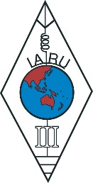 | INTERNATIONAL AMATEUR RADIO UNION  REGION 3  SEVENTEENTH REGIONAL CONFERENCE
10 – 14 September 2018 Seoul, Korea

Document No. 18/XVII/009
Agenda Item: 10.1

Triennial Report of the Radio Amateur Society of Thailand

The people of Thailand were deeply saddened at the passing of the Patron of the Radio Amateur Society of Thailand (RAST), His Late Majesty King Bhumibol Adulyadej, HS1A, in hospital at the age of 88 on October 13, 2016 and his death was followed by a year of mourning throughout the country.
King Bhumibol Adulyadej had been a guiding light in so many fields that it is almost unfair to single out his achievements in just one area such as amateur radio.
Apart from excelling at his royal duties, His Majesty was also an accomplished jazz saxophone player, a sailor and sailboat designer who won a gold medal in the Fourth Southeast Asian Peninsular (SEAP) games in 1967. He also had been an inventor who had been awarded patents for rain-making and for a waste water aerator.
Assigned the callsign HS1A by Thailand's Ministry of Communications in 1989 in a ceremony attended by senior RAST representatives at Chitrlada Palace, King Bhumibol had long experimented with radio communications techniques. These included the deployment of Air Force aircraft to fly in circles while hosting a repeater which was a technique that had enabled His Majesty to communicate between Chiang Mai and Bangkok using a handheld transceiver with less than 1 watt output some 30-40 years ago.
When His Majesty explained this in a televised audience with an Army commander-in-chief a decade or so ago a group of RAST members were inspired to practice stratosphere ballooning which, in turn, led to the JAISAT-1 amateur radio satellite project.
This is Thailand's first amateur radio satellite project which is now almost ready for launching and is sponsored by RAST while being funded by Thailand's regulator the National Broadcasting and Telecommunications Commission (NBTC)
Five years after having received the callsign HS1A, in November 1994 His Late Majesty placed RAST under his royal patronage.
Later, in 2006, His Late Majesty gave advice that reflected both his wisdom and the value of amateur radio communications when he proposed that the telecommunications regulator, then the office of the National Telecommunications Commission (NTC), set up repeaters for amateur radio frequencies in Sukhothai and Uttaradit provinces to provide communications in severely flooded remote areas there.
His Late Majesty had reportedly voiced concern that mobile phones had no signal in the forested areas of the flood-hit provinces and hence his proposal of amateur radio repeaters to help in providing relief.
Following news of the death of King Bhumibol Adulyadej many national events were suspended or postponed, including the annual Amateur Radio Day for 2016 hosted by the NBTC. RAST also postponed the then upcoming Amateur Radio Direction Finding (ARDF) championship that it was about to host and which instead took place during the following year.
Later, in an announcement made in May 2017, CQ Magazine inducted His Late Majesty King Bhumibol Adulyadej into the CQ Magazine Hall of Fame (https://dxnews.com/announce-amaateurradio-hallfame2017/). HS1A-sk then headed a list of 17 people who have "made significant contributions to amateur radio and/or to their professional career fields or some other aspect of life in this world."
While the Late King Bhumibol Adulyadej remains an inspiration to all Thai radio amateurs today, he has been succeeded on the throne by his only son, King Maha Vajiralongkorn.
The Radio Amateur Society of Thailand under the Patronage of His Majesty the King has seen its membership increase by over 56 percent over the past two years, while permission to operate on the six metre band has been granted during several VHF contests.
In addition, there are now many Advanced Class amateur radio operators after the first exam for this class of amateur radio was authorised by NBTC and administered by RAST in June 2016.
Thai Advanced Class examinations were provided for in new regulations governing amateur radio published by the NBTC that became effective in July 2014 following several years of dialogue with RAST and a series of public hearings.
In addition, following a request to the regulator by RAST, foreign radio amateurs living in Thailand who are nationals of 10 countries that share bilateral operating agreements with the Kingdom of Thailand are now eligible to upgrade their Thai licences to Advanced Class which grants them permission to operate with an output power of up to 1 kilowatt.
Activity on the HF bands from Thailand has increased steadily over the past few years and this is borne out by the level of participation in international contests and by the number of QSL cards received by the QSL bureau.
In the period from March 2017 to February 2018 the bureau received a total of 28,453 cards which was 1,000 cards more than during the previous year.
The Thai regulator, the NBTC, has been very supportive of amateur radio and the agency has established the National Subcommittee and Working Group for the Development of Amateur Radio which includes officers from RAST.
As outlined in a strategy paper, the working group's goals include promoting relationships between Thai amateur radio organizations and international amateur radio organizations; to have at least 10,000 intermediate class Thai amateur radio operators within five years – which would be more than a tenfold increase; to devolve more powers to amateur radio organizations at the local level; to provide financial support for Thai amateur radio organizations and to promote more self-regulation by both radio amateurs and the organizations that oversee them.
These objectives reflect the NBTC's commitment to the development of amateur radio. RAST's President Jakkree Hantongkom, HS1FVL and senior committee members who have frequent contact and interaction with the agency's commissioners and its senior staff members have observed that the NBTC has a very positive attitude towards amateur radio and its role in society.
As of February 2018 Thailand had a total of 100,800 Novice Class amateur radio operators, 703 Intermediate Class operators and 260 Advanced Class operators for a total of 101,763 operators in the country, placing Thailand as the country with the third highest number of licensed radio amateurs after the United States of America and Japan.
Meanwhile, as of January 1, 2018 RAST has a total of 1122 members, of whom 1113 are transmitting members. This number comprises 908 life members, 202 annual members and 12 club station members and reflects a strong growth in RAST's membership of over 25 percent a year for each of the two previous years.
The society holds monthly social gatherings on the first Sunday of each month and has web sites in Thai (www.rast.or.th) and in English (www.qsl.net/rast) while RAST has a club station with the callsign HS0AC with teams that compete in major amateur radio contests. RAST also has a Facebook page at https://www.facebook.com/rast.org/
The club station recently moved from a location outside Bangkok at the Asian Institute of Technology (AIT) to the campus of Rajapruk University which is in the northern suburbs of the city. The relocation was made because of damage to the foundations of the station at AIT sustained during severe flooding in 2011.
RAST is also working on a project to launch an amateur radio satellite (JAISAT-1) which has been funded to the tune of over nine million baht by NBTC's Broadcasting and Telecommunications Research and Development Found for Public Interest (BFTP).
Work continues on this CubeSat satellite which is taking place here in Thailand and also in the Netherlands where Innovative Solutions in Space (ISIS) is contracted to provide its expertise to assemble the satellite and it should be launched from India in the near future. A ground station with the callsign HS0AJ has been authorised and is already tracking satellites and providing online access (https://sites.google.com/site/orgrast/jaisat/live).
In 2016, RAST hosted the 44th annual SEANET Convention in the seaside resort of Pattaya that was attended by some 150 delegates from 18 countries. This had been the tenth time that RAST had hosted this annual event, having previously staged SEANET conventions in Bangkok on five occasions as well as hosting the convention in the northern Thai towns of Chiang Mai and Lampang while it had also been held previously in Pattaya in the year 2000 and on Koh Samui, an island in the Gulf of Thailand, back in 1995.
Representatives of RAST, including committee members, attend the annual SEANET conventions every year, while also participating in the IARU Region 3 triennial conferences, including the previous conference in Bali, Indonesia in 2015.
RAST also takes part in national and international amateur radio exhibitions and participates in amateur radio conventions and for the past several years has had a booth at the Friedrichshafen Ham Fair in Germany and at the Tokyo Ham Fair in Japan.
The society also participates in the NBTC's annual Amateur Radio Day exhibition and conference with a booth which has been held every December since 2014, with the exception of 2016 following the passing of His Late Majesty King Bhumibol Adulyadej, and the society also participated in the Maker Faire exhibitions in Bangkok in 2016 and 2017 and in the Intellectual Property Innovation Fair in Bangkok in 2017.
The society has also co-operated with universities in Thailand by participating in a Home School Workshop to promote knowledge among children at the Faculty of Liberal Arts at Chulalongkorn University and took part in a seminar about the Knowledge about Telecommunications of His Majesty the King Rama 9 at Kasetsart University Demonstration School. Both events took place in August 2017.
In promoting knowledge and awareness of the role that amateur radio can play in disaster prevention and mitigation, RAST has joined preparedness training exercises in conjunction with the Royal Thai Army and with the Ministry of Interior while it has also taken part in many events organised by the Ministry of Digital Economy and Society (formerly known as the Ministry of Information and Communication Technology or MICT).
RAST also works closely with the NBTC Secretariat by conducting training courses for staff members about amateur radio and by briefing officials about upcoming international issues, such as prior to the World Radio Conference in 2015, while it is now readying for WRC-19, pointing out significant issues to officials such as the growing problem of interference from wireless power transfer (WPT) for electric vehicles.
In addition to invigilating and administering amateur radio examinations for the NBTC, RAST also conducts US FCC examinations that are administered by Thai volunteer examiners (VECs) which enable Thai Novice Class operators to upgrade their licences to an Intermediate Class licence by obtaining a US amateur radio licence.
These exams are organised by RAST Secretary Chalermphol Muangamphun, E21EIC and conducted every few months and have been staged in many provinces of the country, as well as in the neighbouring country of Malaysia in conjunction with the Malaysian Amateur Radio Transmitting Society (MARTS).
Contesting is at the heart of amateur radio in Thailand and back in the 1980s contest participation by RAST played a key role in persuading the authorities to grant permission for the activity. Back in 1982, the regulator at the time, the Post and Telegraph Department (PTD), had forbidden all amateur radio operators from getting on the air while amateur radio regulations were being drafted.
RAST then applied to operate from a club station in major international contests from an academic campus and, with HF amateur radio operations otherwise forbidden, these repeated requests – which were all granted – meant that Thailand could remain active on the HF amateur radio bands.
And, as it turned out, this participation in international contests would enable HF activities to continue in Thailand for five years during the mid-1980s before new regulations were drafted and licensed HF amateur radio finally took off.
Those operations had also helped to convince the Thai authorities that the hobby offered many benefits while also demonstrating the high level of interest in Thailand.
This contest activity achieved several objectives. These included maintaining Thailand's presence on the HF bands at the time and allowing hams in other countries to contact Thailand while also reminding the Thai authorities, who were drafting amateur radio regulations during this period, of the enthusiasm among Thais and expatriate residents to get on the air.
The legacy that contesting has had in promoting amateur radio along with a growing interest in HF activity is reflected by a steady increase in participation by Thai radio amateurs in international contests.
This is evidenced by the number of stations in Thailand submitting logs in the CQ World Wide contests, both for SSB and CW, which has been steadily increasing over the past few years. This can be seen in the chart below, which shows that the total number of contest logs submitted for these contests had increased from 17 in 2010 to 58 in 2016.

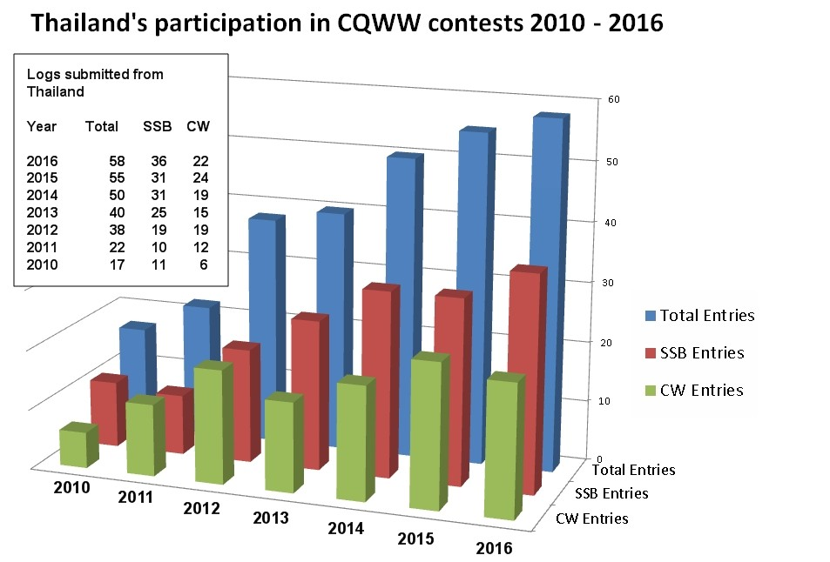

And even today, participating in contests is still used as a means of getting permission to operate on amateur radio spectrum that is not available to operators on a day-to-day basis.
Following a request from RAST, earlier in 2018 the NBTC granted temporary permission for Intermediate and Advanced Class amateur radio operators and club stations with HF operators to operate throughout the 80 metre band and on the six metre band in a total of 14 amateur radio contests.
This authorisation was for HF and VHF contests and allowed intermediate and advanced class amateur radio operators to operate on frequencies from 3.5 MHz to 3.9 MHz during eight international HF amateur radio contests and from 50-54 MHz during six VHF amateur radio contests.
The only requirement was that RAST must be notified by stations which intended to take advantage of this and RAST, in turn, would inform the NBTC Secretariat accordingly of this information.
RAST would like to also take advantage of this country paper to congratulate the IARU Region 3 on the occasion of its 50th Anniversary and, as of June 2018 and until October 31 the society is operating a special event station using the callsign HS50IARU as part of the 50th Anniversary Award.

This paper was prepared by Tony Waltham, HS0ZDX and G4UAV, RAST Vice President and International Liaison Officer. Email: tony.waltham@gmail.com

