 | INTERNATIONAL AMATEUR RADIO UNION  REGION 3  SIXTEENTH REGIONAL CONFERENCE | 
12 – 16 October 2015 Bali, Indonesia

Document No. 15/XVI/054
Agenda Item: 10.1.23

REPORT FROM CRSA/CRAC

THE AMATEUR RADIO IN THE MAINLAND OF CHINA

The Chinese Radio Amateurs Club
The Chinese Radio Sports Association

ONE – The reforming of national amateur radio organization
The national amateur radio organization of Mainland China is being under reforming. Its new form will be Chinese Radio Amateur Club, abbreviated as CRAC. The existing amateur radio organizations will become a part of it. By now some domestic coordination procedure is in the final stage on its way and will soon be completed. The temporary acronym CRSA/CRAC used for the delegation reflects the state of this on-going process.
TWO – The statistics
1. The population of new operators
After the new amateur radio regulation was adopted from 2013, a new licensing examination network has been extended across all 31 provinces, autonomous regions and municipalities in the mainland of China. Over 400 examines were organized since then.
According to the new regulation, the licensing examination for operation on type-A and type-B amateur stations can be conducted by local radio administrations, and the local amateur radio organizations committed by radio administrations as well. The examination for type-C is only committed to CRAC by the administration. All certificates are uniquely numbered by CRAC, this ensures the accurate nation-wide database of amateur operators can be maintained by CRAC.
The population of amateur radio operators newly certified during 2013-31st July 2015 is as following:
Certification Type | Number of operators
A | 26,927
B | 3,649
C | 182
Total | 30,758
Among the above figures, operators of type-A are all new, but of type-C or type-B could be upgrading old operators.
2. The population of active old operators
According to the old database of CRSA, the accumulative population of certified operators in 1993-2012 was over 120,000. However, a certain part of it was being lost along the time due to different reasons.
As per the requirement from the radio administration, all old certificates for operation were required for renewing before the middle of 2015. The population of amateur radio operators who have renewed the certificate is as following:
Certification Type | Number of operators
A | 21,714
B | 7,056
C | 257
Total | 29,027
This figure can be interpreted as the old operators who are still active.
3. Total population of active operators
So the total number of active amateur radio operators in the mainland of China is about 60,000..
4. The total number of amateur stations
Because the station license is issued by different provincial radio administrations, CRAC currently does not hold an accurate statistic of stations. However, after 2013 many provincial radio administrations have made the operator certifying and the station licensing into one service package, so that the number of amateur stations should be only slightly lower than the total population of active operators.
5, The age and gender distribution
The age and gender distribution of newly certified operators for each type of amateur station is illustrated in the following graphs:
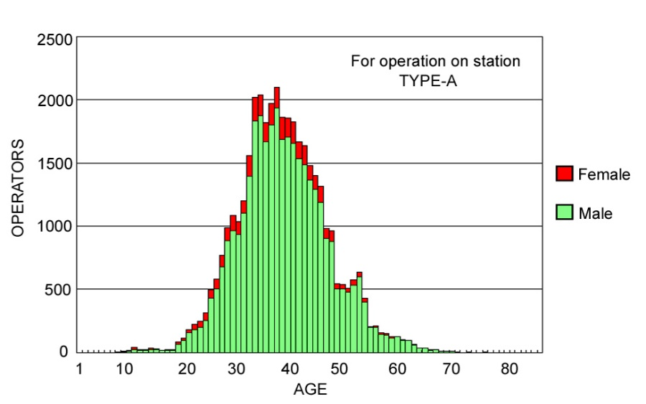
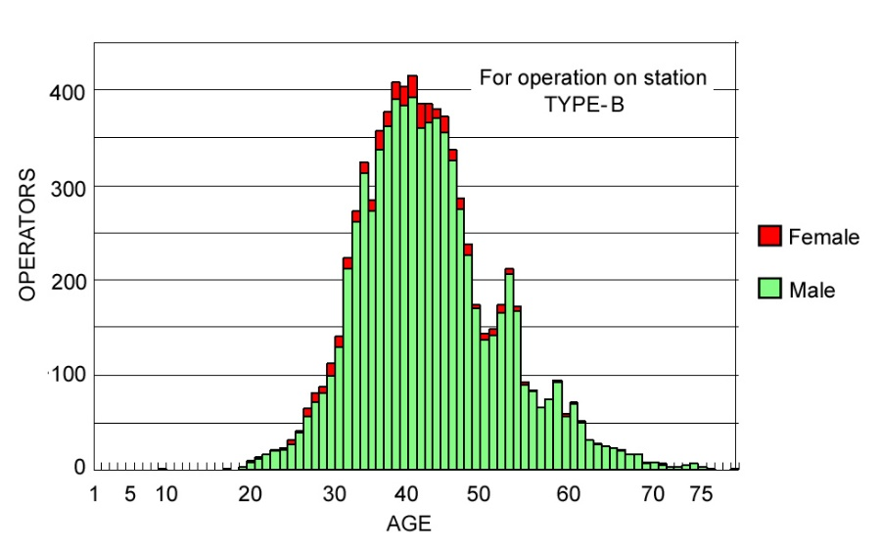
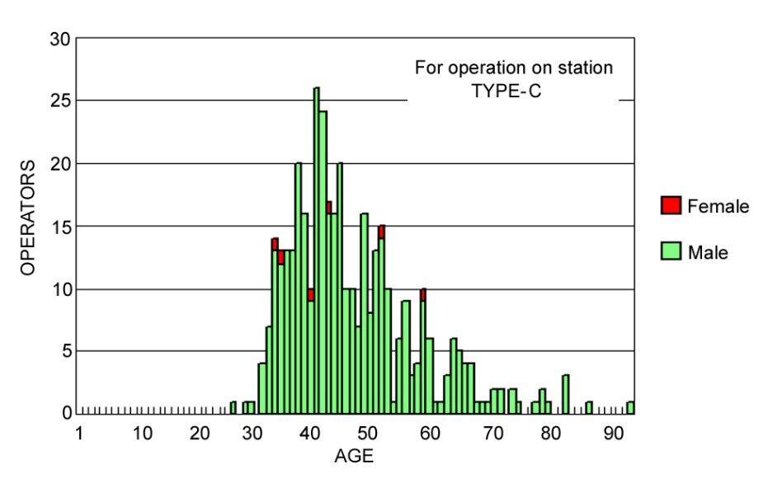
A peak age appears at about 40. This could be younger than in some other countries, because we lost a generation of old-timers in the interval of 1950-1980s.
Obviously, the percentage of women operator is lower.
6. The membership of amateur radio organizations
In the past any person who wants to get am amateur station license was demanded to be the member of Chinese Radio Sports Association. Theoretically, the CRSA member population should be equal to that of the station license holder. It would be less than the population of certificate holder because a significant portion of them did not completed the procedure for station license, it still was a good number.
Because the obligatory membership requirement is removed in the new regulation adopted since 2013, the society membership of old operators is being losing dramatically, and most of new operators have not applied for any society membership yet. The fluctuations have not subsided and it is very hard to make any conscious membership statistics at this moment.

THREE – The new regulation of amateur radio administration
The new regulation, “The Regulation of Amateur Radio Administration” with related bylaws, was released by the national radio administration of China, The Ministry of Industry and Information (MII), at the end of 2012 and came into effect since 2013.
The new regulation is focused on meet the booming demanding from the smooth growing amateur services in China, it is also merged with the experiences gained from the amateur radio administration during the past 20 years. Chinese Radio Amateur Club has taken an important part in the drafting, discussing and finalizing phases of the legislation.
Comparing with the previously used “The Tentative Regulation of Amateur Radio Administration” of 1992, some significant highlights and improvements can be observed from new regulation, which may apply positive influence to the further growth of amateur service. More detailed information can be found in annex 1.

FOUR - The relationship with radio administration
CRAC has good relationships with the national radio administration. CRAC is committed by the national administration to conduct the amateur radio operator certificating systems, to organize the major amateur radio activities and the self-discipline on frequency utilizations, and to make advices to the administrations.
CRAC keeps unhindered communications with the terrestrial service department and the space service department of the national radio administration bureau. This enables CRAC to submit the requirements and comments arisen from radio amateurs timely and thus reflect the interest of amateur services promptly.
FIVE - The preparation for WRC-15
CRAC has been actively involved in the preparation for WRC-15, mainly focused on Agenda Item 1.4. So far CRAC participated in all domestic preparation meetings regarding the agenda items related to amateur and amateur satellite services and created cooperative and friendly relationships with other working parties, and have made intensive technical discussions with the WRC project team, especially fully expressed the importance of 5MHz band to amateur radio emergency communications in disasters.
Considering the strong defensive position of existing services within this frequency range, CRAC aimed to pursuit other services to support Method A3, seeking a new allocation to the ARS of a continuous 15 kHz segment, on a secondary sharing basis, in any range within 5,250 - 5,450 kHz, with maximum transmitting power of E.I.R.P. 30W, and applied with listen-before-talk procedure.
By the time this report is drafted, this effort appears prospective.

SIX – The amateur frequency bands
1. The frequency allocated to amateur and amateur satellite services
The frequency allocated to amateur and amateur satellite services is stipulated in the “Regulations on the Radio Frequency Allocation” of China, which is published as a book and basically revised after each WRC. Every detail of this document is in compliance with the Table of Frequency Allocations plus the related footnotes in ITU-RR Articles 5.
- 7 MHz band expansion of WRC-03
The 7,100 – 7,200 kHz expansion is allocated to amateur and amateur satellite services in China since the ITU allocation was made at WRC-03. Practically it is being used by domestic amateur stations in a random basis.
- 475 KHz allocation of WRC-12
As registered in the footnote 5.80B of ITU-RR, the 472 – 479 kHz band is not available for amateur services in China.
- 136 kHz allocation of WRC-07
The 135.7-137.8 kHz band is allocated to amateur and amateur satellite services in China.
However, no report of successful domestic practice on this band has been received from radio amateur yet. Due to most amateurs live in dense populated residential area, the space limitation for LF antenna and the increasing EM noise floor are considered the main impact to the amateur application in this band.
5. Frequency used in disaster emergency communications
The VHF/UHF bands frequently used in disaster emergency communication in the mainland of China are 144 MHz and 430 MHz band, direct or via repeater, FM or digital voice. The HF bands frequently used in disaster emergency communication are 7MHz and 14MHz, mainly on SSB phone. The exact frequencies are normally selected locally, according to the environment condition in the time.
6. CARC band plan
A draft of band plan with the net controlling and common calling frequencies for emergency communication was made and distributed among amateurs for discussing in 2012, as shown in annex 2. However, it has not been specifically implemented yet.
One of the major trades off being considered is about the selection of HF emergency calling frequency. There are some popular daily traffic frequencies in China like 7,050 kHz and 14,270 kHz, on which there are relatively more amateur stations keeping listening. Take them for emergency calling would greatly increase the hit rate for response, but the shortcoming of this would be more QRMs caused by normal traffic. Contrarily, separate dedicated emergency calling frequencies may get less interference, but the shortcoming is that the limited long-term monitoring resource will be scattered, thus the capture rate of the emergency call would drop down, which could be fatal.
By now the study on how to make an optimized band plan is still carried on. The consistent with IARU Region 3 band plan is one of the preferential considerations.

SEVEN – Amateur Radio Disaster Communication
In the past 10 years, China amateur radio society actively participated in IARU Region 3 Disaster Communications Committee activities. Align with IARU guidance, CRAC / CRSA have made bast effort in develop China’s amateur radio disaster communication.
1, CRAC/CRSA organized and encouraged actively participated in GlobalSET (Simulated Emergency Test), which organized by IARU disaster communication committee and submit report. So far more than 10 stations acted as HQ station or participation station. Build regular connection with other member societies.
2, In case of disaster in neighboring countries, CRAC/CRSA was always activate the coordinate on HF bands reminding domestic amateur stations to keep clear of the emergency frequencies. In the past major earthquake disasters the relief team formed by radio amateurs with HF equipment were mobilized timely and able to arrive on site quickly. Also some cross board international cooperation was realized. We sent two Chinese amateur radio operators to Nepal in Apr 2015 to join the relief service for the Nepal earthquake.
3, Most of the cities in China have volunteer disaster rescue organizations cooperated with government rescue force. These organizations normally have a disaster communication section, generally propped up by amateur radio operators. This localized structure is well fit the hierarchical concept of the government disaster rescue policy and makes amateur radio to provide efficient and effective disaster communication services for any emergency incidents.
4, There are annual disaster communication simulation test and competition in different cities, the training items mainly include HF station quick set up, VHF/UHF repeater set up, operation site preparation, amateur radio message relay, etc.
5, CRAC/CRSA is staring to build up the cross-city repeater network, an experimental digital repeater trunk-link between Beijing and Nanjing has been in test since 2012. Considering the HF hop of 1000 – 2000km could be the best path between the destructive disaster center and outside world, the HF diversify receiving network was experimentally tested using SDR.
6, Amateur radio technical group has designed a couple of easy-to-use emergency VHF/HF/Repeater pack set for quick response. Some are powered by solar.
Going forward, the CRAC/CRSA will enhance the cooperation with IARU and it’s member societies in disaster response, and will also be focused in establish a domestic internetworking system dedicated in maximize the total power of amateur radio emergency communication, create closer cooperation and coordination with governmental and professional disaster rescue forces, and provide more training in emergency radio communications.

EIGHT – The domestic coordination in amateur satellite service
In the recent two years some universities and research institutes in China become greatly interested in designing and operating small satellites. Some of them have got opportunities for free ride, as a consequence, a number of amateur satellite projects are established last year. Amateur radio beacons, amateur transponders and amateur digipeaters are being carried on several small satellites and were launched about a month ago, namely, 7 spacecrafts in CAS-3 satellites group and 3 in SECM-1.
However, amateur satellite service is new to most of Chinese hams in the project teams. Due to the rush schedule for the free ride, the time is too short for them to gain all necessary knowledge and experience, not only in technical aspects, but especially in the international obligation related to satellite, the procedures of ITU frequency information submission and IARU amateur satellite frequency coordination, and the band plans of other IARU regions. This surely may cause some misunderstanding and bring some problems.
To make all these amateur satellite jobs packed into the framework of ITU Radio Regulation, thus protect the interest of radio amateurs and prevent the risk of potential harmful interference to the amateur services in other regions and countries, CRAC keeps close liaison with all related parties, including the space services department of national radio administration, the ham members in the satellite project teams, and the IARU amateur satellite frequency coordination panel, and plays an active role in domestic coordination by seeking the realistic solutions.
CRAC believes as the technical progress of launching and constellation, more radio amateurs will be interested in amateur satellite service and more opportunities for small amateur satellite launching may appear. To avoid all possible problems in very early stage of satellite projects is vital. So that the most important job for CRAC is to help the administration to educate the potential amateur satellite operators about ITU regulations and amateur radio self-disciplines, and create a perfect flowchart for amateur satellite operations to follow in the future. To do this, CRAC has organized and participated in five educational seminars for all Chinese amateur satellite project teams since the end of 2014.

Annex 1

Highlights in the new amateur radio regulation

- The government policy of supporting amateur radio is clarified in clause
It is written in a clause read as:
“The country encourages and supports the technical study, popularization, and the emergency communication actions under the urgent situation such as major natural disaster.
“The legal amateur radio station is protected by the laws and regulations of the Country.”
2. The amateur radio administration system is simplified
Some assistant front-end servicing job in amateur radio administration was committed to sports agency by the radio administration during 1990-2012.
By the new regulation, the radio administration will be uniquely responsible all the way in the amateur radio administration. This makes the licensing procedure simplified and straightforward, and thus makes the radio amateurs much easier.
3. The two-layer architecture
The previous two-layer architecture of amateur radio administration is maintained by the new regulation. The Country layer is at the Radio Administration Bureau under the Industry and Information Ministry, while the local layer is at the provincial radio administration departments in government.
The ordinary amateur stations and repeaters are subjected to be licensed at the local layer and is convenient for radio amateurs. The special amateur stations such as beacons or space stations carried on satellite are subjected to be licensed at the Country layer.
4. The classification and the legal power of amateur stations
By the new regulation, amateur stations are classified into three categories as following:
Category | Frequency to use | Legal transmitting power
Type-A | All amateur bands above 30MHz | Not greater than 30W
Type-B | All amateur bands | Above 30MHz: Not greater than 30W  Below 30MHz: Not greater than 100W
Type-C | All amateur bands | Above 30MHz: Not greater than 30W  Below 30MHz: Not greater than 1000W
5. The two-license system
The previous two-license system for amateur radio is maintained by the new regulation.
The license to operate, called as the certificate for amateur radio operation, is issued to a technically qualified person. The station license is issued to an amateur radio station which meets the technical specification and owned by a certified operator.
6. The age limit for certification
There is no age limit to obtain a certificate for amateur radio operation. With the certificate an operator may transmit from own or any others station. However, the applicant for a station license must be at least 18 years.
7. The obligatory membership requirement is removed
During 1992-2012, any amateur radio station licensee was compelled for the membership of designated society. The new regulation removes this prerequisite, thus gives the licensee more free personal choices.
This new method is widely welcome by radio amateurs. However in another hand, the member population of national and local amateur radio societies would be facing a dramatic decreasing.
8. The mobile operation
The ordinary amateur stations are licensed by each local radio administration, the executive authority of which is bounded within a province by the law. Previously there was no any prohibition to amateur mobile operation, but when an amateur station moves from its residential province to another, the legality question could be arisen theoretically.
The new regulation solves this issue in the following way. An applicant for amateur station license may declare if mobile operation is desired. If so, the authorization from Country to local administration will be automatically effected to make the station license valid across all provinces.
9. The technical requirement for amateur radio transmitting devices is embodied
General radio regulations of China require that transmitter used in radio station shall be type-approved. But the technical standard dedicated for amateur transmitter is still on the way, while the existing standard for general commercial radio includes too many professional requirements which discourage the amateur radio manufacturers in type-approving.
In the new regulation, the technical requirement for the type-approve of transmitter exclusively used in amateur station is practically described, which is made compatible with popular international standards. That incites the manufacturers to have amateur equipment type-approved.
In addition, any DIY, assembled and modified transmitting equipment may also be used in amateur station provided it is passed case by case test. The new requirement also brings lot of convenience to the radio amateurs who use these non-type-approved rigs.
10. The term of validity of amateur radio station license is extended from 3 years to 5.
11. New regulation applies to foreigners who live in China
According to the previous regulation, the applicant for amateur station shall be with Chinese nationality. This condition is no longer included in the new regulation.
That gives the possibility to the person other than Chinese citizen to apply for setting up amateur radio station, if he/she is granted a certificate for amateur radio operation by pass the same licensing examination as for Chinese, and has a relatively stable residence in China.
For the person who has been granted a license to operate amateur station by another administration and is to be temporarily stay in the territory of China, a temporary certificate for operation and be applied from the national amateur radio society. With the temporary certificate, only guest operation from existing Chinese amateur radio stations is allowed.
Annex 2

CRAC BAND PLAN
（a draft for discussing）

Band | Mode/Application | Unit | Frequency | Frequency for  emergency net control/common call
 |  |  |  | Domestic | IARU R3
135kHz | CW/NB | kHz | 135.7-137.8 | - | -
1.8MHz | CW | MHz | 1.800-2.000 | - | -
1.8MHz | RTTY DX window | MHz | 1.830-1.834 | - | -
1.8MHz | Phone | MHz | 1.840-2.000 | - | -
3.5MHz | CW | MHz | 3.500-3.900 | 3.600 | 3.600
3.5MHz | CW DX window | MHz | 3.500-3.510 | 3.600 | 3.600
3.5MHz | Phone | MHz | 3.535-3.900 | 3.600 | 3.600
3.5MHz | Phone DX window | MHz | 3.775-3.800 | 3.600 | 3.600
7MHz | CW | MHz | 7.000-7.025 | 7.030 （CW/NB）  7.050（SSB） | 7.110
7MHz | NB | MHz | 7.025-7.040 | 7.030 （CW/NB）  7.050（SSB） | 7.110
7MHz | Phone | MHz | 7.030-7.200 | 7.030 （CW/NB）  7.050（SSB） | 7.110
10MHz | CW | MHz | 10.100-10.150 | 10.145（CW/NB） | -
10MHz | NB | MHz | 10.140-10.150 | 10.145（CW/NB） | -
14MHz | CW | MHz | 14.000-14.350 | 14.050（CW/NB）  14.270(SSB) | 14.300
14MHz | NB | MHz | 14.070-14.112 | 14.050（CW/NB）  14.270(SSB) | 14.300
14MHz | Beacon | MHz | 14.0995-14.1005 | 14.050（CW/NB）  14.270(SSB) | 14.300
14MHz | Phone | MHz | 14.100-14.350 | 14.050（CW/NB）  14.270(SSB) | 14.300
14MHz | SSTV | MHz | 14.225-14.235 | 14.050（CW/NB）  14.270(SSB) | 14.300
18MHz | CW | MHz | 18.068-18.168 | 18.160 | 18.160
18MHz | NB | MHz | 18.100-18.110 | 18.160 | 18.160
18MHz | Beacon | MHz | 18.1095-18.1105 | 18.160 | 18.160
18MHz | Phone | MHz | 18.110-18.168 | 18.160 | 18.160
21MHz | CW | MHz | 21.000-21.450 | 21.080（CW/NB）  21.400(SSB) | 21.360
21MHz | NB | MHz | 21.070-21.125 | 21.080（CW/NB）  21.400(SSB) | 21.360
21MHz | Beacon | MHz | 21.1495 21.1505 | 21.080（CW/NB）  21.400(SSB) | 21.360
21MHz | Phone | MHz | 21.125-21.450 | 21.080（CW/NB）  21.400(SSB) | 21.360
21MHz | SSTV | MHz | 21.335-21.345 | 21.080（CW/NB）  21.400(SSB) | 21.360
24MHz | CW | MHz | 24.890-24.990 | - | -
24MHz | NB | MHz | 24.920-24.930 | - | -
24MHz | Beacon | MHz | 24.9295-29.9305 | - | -
24MHz | Phone | MHz | 24.930-24.990 | - | -
28MHz | CW | MHz | 28.000-29.700 | 28.080（CW/NB）  28.400（SSB）  29.600（FM） | -
28MHz | NB | MHz | 28.050-28.150 | 28.080（CW/NB）  28.400（SSB）  29.600（FM） | -
28MHz | Beacon | MHz | 28.200 +/- 500Hz | 28.080（CW/NB）  28.400（SSB）  29.600（FM） | -
28MHz | Phone | MHz | 28.300-29.300 | 28.080（CW/NB）  28.400（SSB）  29.600（FM） | -
28MHz | SSTV | MHz | 28.675-28.685 | 28.080（CW/NB）  28.400（SSB）  29.600（FM） | -
28MHz | Satellite | MHz | 29.300-29.510 | 28.080（CW/NB）  28.400（SSB）  29.600（FM） | -
28MHz | WB | MHz | 29.510-29.700 | 28.080（CW/NB）  28.400（SSB）  29.600（FM） | -
50MHz | CW | MHz | 50.000-54.000 | - | -
50MHz | Beacon | MHz | 50.050-50.100 | - | -
50MHz | CW/Phone/NB/WB | MHz | 50.100-54.000 | - | -
144MHz | EME | MHz | 144.000-144.035 | 145.000  Local Repeater  APRS | -
144MHz | CW/Phone/NB/WB | MHz | 144.035-145.800 | 145.000  Local Repeater  APRS | -
144MHz | Satellite | MHz | 145.800-146.000 | 145.000  Local Repeater  APRS | -
144MHz | All mode | MHz | 146.000-148.000 | 145.000  Local Repeater  APRS | -
430MHz | CW/Phone/NB/WB | MHz | 430.000-431.900 | 435.000  Local Repeater  APRS | -
430MHz | EME | MHz | 431.900-432.240 | 435.000  Local Repeater  APRS | -
430MHz | CW/Phone/NB/WB | MHz | 432.240-435.000 | 435.000  Local Repeater  APRS | -
430MHz | Satellite | MHz | 435.000-438.000 | 435.000  Local Repeater  APRS | -
430MHz | CW/Phone/NB/ WB | MHz | 438.000-439.000 | 435.000  Local Repeater  APRS | -
Note: Segment for beacon is exclusive. No transmission of other application shall be in it.

____________________

